

MINISTRY OF EDUCATION AND TRAINING

HO CHI MINH CITY UNIVERSITY OF TECHNOLOGY AND EDUCATION

FACULTY OF INTERNATIONAL EDUCATION



DEEP LEARNING

FACE RECOGNITION

**STUDENTS: GROUP 05**

Bùi Ngọc Ánh 20110354

Lý Hồng Khanh 20110373

Trần Minh Gia Khánh 20110374

Nguyễn Huỳnh Thanh Toàn 20110420

Phạm Vũ Đăng Khoa 20145393

**ADVISOR:** TRẦN NHẬT QUANG

Ho Chi Minh City, May 2023

|  |  |
| --- | --- |
| HO CHI MINH CITY UNIVERSITY OF TECHNOLOGY AND EDUCATION  FACULTY OF INFORMATION TECHNOLOGY  ******* | **SOCIALIST REPUBLIC OF VIET NAM**  **Independence – Liberty – Happiness**  **\*\*\*\*\*\*\*** |

ADVISORS’S EVALUATION FORM

Full name of student 1: Bùi Ngọc Ánh Student ID 1: 20110354

Full name of student 2: Lý Hồng Khanh Student ID 2: 20110373

Full name of student 3: Trần Minh Gia Khánh Student ID 3: 20110374

Full name of student 4: Nguyễn Huỳnh Thanh Toàn Student ID 4: 20110420

Full name of student 5: Phạm Vũ Đăng Khoa Student ID 5: 20145393

Major: Information Technology

**Topic:** Creating A Social Networking Platform to Assist Parents In Raising Their Children.

Full name of Advisors: Trần Nhật Quang

**FEEDBACK**

1. Regarding the content of the topic and the scope of implementation:

1. Advantages:

1. Drawbacks:

1. Recommendation for thesis defense, or not?

1. Classification assessment:

1. Grade:

|  |
| --- |
| *Ho Chi Minh City, May 14th 2023* |
| Advisors |
| *(Sign & Full name)* |

ACKNOWLEDMENT

First, we would like to express our sincere gratitude to the Faculty of International Education of Ho Chi Minh City University of Technology and Education for providing us with the opportunity to study, develop a deep knowledge base and carry out this project.

In addition, we would like to extend our deepest thanks to Mr. Tran Nhat Quang. Throughout the long process of studying and completing the project, Mr. Quang has devotedly and enthusiastically guided us from the beginning to the end. This will be a great asset for us before stepping into a new life.

However, knowledge is limitless and with our limited abilities, we have tried our best to complete this project. Therefore, it is difficult to avoid mistakes. We hope to receive your constructive feedback so that we can learn from our experiences and improve our product in the best way possible.

Lastly, we would like to express our deepest gratitude to Mr. Quang and the esteemed faculty members of the Faculty of International Education at Ho Chi Minh City University of Technology and Education. We wish you all good health. We sincerely thank you.

We sincerely thank you!

|  |  |
| --- | --- |
| Implementation Group | |
| Bùi Ngọc Ánh | 20110354 |
| Lý Hồng Khanh | 20110373 |
| Trần Minh Gia Khánh | 20110374 |
| Nguyễn Huỳnh Thanh Toàn | 20110420 |
| Phạm Vũ Đăng Khoa | 20145393 |

**TABLE OF CONTENT**

CONTENT 13

CHAPTER 1: INTRODUCTION DEEP LEARNING 13

1.1. SHOULD I LEARN DEEP LEARNING? 13

CHAPTER 2: INTRODUCTION TO ARTIFICIAL NEURAL NETWORKS 14

2.1. BIOLOGICAL NEURONS. 14

2.2. BIOLOGICAL NEURAL NETWORKS. 14

2.3. ARTIFICIAL NEURONS. 15

2.4. ARTIFICIAL NEURAL NETWORKS. 16

2.5. OUTPUT OF AN ARTIFICIAL NEURON. 16

2.5.1. Each input gets scaled up or down 16

2.5.2. All signals are summed up 17

2.5.3. Activation 17

2.5.4. Activation functions 17

2.5.5. Forward propagation and Backpropagation 17

2.5.6. Using NNs 19

CHAPTER 3: INTRODUCTION TO ANNS 22

3.1. BUILD YOUR FIRST NNS USING SEQUENTIAL API 22

3.2. NONSEQUENTIAL NNS - FUNCTIONAL API 22

3.3. SUBCLASSING API 24

3.3.1. Static models 24

3.3.2. Dynamic models 25

3.4. CALLBACKS 25

3.5. HYPERPARAMETER TUNING 26

3.5.1. NN’s hyperparameter 26

3.5.2. Number of Hidden layers 26

3.5.3. Other hyperparameters 27

3.5.4. Libraries for NN hyperparameter tuning 28

CHAPTER 4: TRAINING DEEP NEURAL NETWORKS 30

4.1. SHALLOW VS DEEP NNS 30

4.2. VANISHING/EXPLODING GRADIENTS PROBLEMS 30

4.3. SOLUTIONS FOR THE GRADIENT PROBLEMS 30

4.4. KERAS IMPLEMENTATION 31

4.5. ACTIVATION FUNCTIONS 31

4.6. TIP AND IMPLEMENTATION 35

4.7. BATH NORMALIZATION 35

4.8. GRADIENT CLIPPING 36

4.9. USING PRETRAINED LAYERS 37

4.10. LEARNING RATE SCHEDULING 38

4.11. LEARNING CURVE. 38

4.11.1. Time-based decay scheduling 39

4.11.2. Exponential scheduling 40

4.11.3. Piecewise constant scheduling 41

4.11.4. Performance scheduling 42

4.11.5. 1 cycle scheduling 43

4.12. Comparison learning schedules 44

4.13. Regularization 45

4.13.1. L1 and l2 regularization 46

4.13.2. Dropout: 47

4.13.3. Max-norm regularization 49

4.14. Comparision regularization techniques 49

CHAPTER 5: PREPROCESSING DATA WITH TENSORFLOW 51

5.1. Preprocessing 51

5.1.1. Definition 51

5.1.2. How it works 52

5.2. Methods 52

5.2.1. DataApi 52

5.2.2. Chaining Transformations 53

5.2.3. Shuffling the Data 54

5.3. Prefetching and Multithreading 57

5.3.1. Prefetching 57

5.3.2. Multithreading 58

5.4. Comparision 59

5.5. Embedding 60

CHAPTER 6: COMPUTER VISION USING CONVOLUTIONAL NEURAL NETWORKS 63

6.1. CONVOLUTIONAL NEURAL NETWORKS 63

6.2. Convolutional layers 63

CHAPTER 7: CNN ARCHITECTURES 66

7.1. LeNet-5 66

7.1.1. Definition 66

7.1.2. Architectures 66

7.1.3. Advantages 67

7.1.4. Disadvantages 67

7.2. AlexNet 67

7.2.1. Definition 67

7.2.2. Architecture 67

7.2.3. Advantages 69

7.2.4. Disadvantages 69

7.3. GoogleNet 69

7.3.1. Definition 69

7.3.2. Architectures 69

7.3.3. Advantages 71

7.3.4. Disadvantages 71

7.4. ResNet 71

7.4.1. Definition 71

7.4.2. Architecture 71

7.4.3. Advantage 72

7.4.4. Disadvantages 73

7.5. Xception 73

7.5.1. Definition 73

7.5.2. Architecture 73

7.5.3. Advantages 74

7.5.4. Disadvantages 74

7.6. SENet 75

7.6.1. Definition 75

7.6.2. Architecture 75

7.6.3. Advantages 77

7.6.4. Disadvantages 77

7.7. Comparison between CNNs architectures 77

CHAPTER 8: OBJECT DETECTION 79

8.1. Introduction 79

8.1.1. Definiton 79

8.1.2. Compare Object detection and Classfication. 79

8.1.3. Structural of Object Detection 79

8.2. To detect multiple objects 79

8.2.1. Sliding CNNs 79

8.2.2. Non-max suppression 79

8.2.3. Fully convolutional network 80

8.3. Measure Mean Average Precision (mAP) 80

8.4. Computer vision problem. 81

CHAPTER 9: PROCESSING SEQUENCES USING RNN 82

9.1. Introduction 82

9.1.1. Definition 82

9.2. RNN’s fundamental concepts 82

9.2.1. Recurrenth neurons 82

9.2.2. Weight of recurrent neurons 82

9.2.3. Input and output of RNNs 83

9.2.4. Time series 83

9.3. Variants of LSTM Cells and Other NNS that Handles sequential data 83

9.3.1. RNNs with 1D conv layers 83

9.3.2. WaveNet 83

PROJECT: FACE RECOGNITION 85

1. LIBRARIES 85

1.1. ARCFACE MODEL 85

1.2. MTCNN (Multi-task Cascaded Convolutional Networks) 85

2. MODEL ARCHITECTURE 85

3. DATASET 86

4. DATASET PRE-PROCESSING 89

5. MODEL TRAINING 90

5.1. GET EMBEDDING IMAGE DATA 90

5.2. TRAIN RECOGNITION MODEL 91

6. Mark Attendance 93

7. APPLICATION DEMONSTRATION 95

7.1. Collect dataset 95

7.2. Normalize dataset 95

7.3. Train model: 96

7.4. Realtime Recognition: 99

REFERENCES 102

**LIST OF FIGURES**

Figure 1. A biological neuron. 14

Figure 2. Human cortex. 15

Figure 3. Components of Artificial neurons. 15

Figure 4. Three processing steps of calculations inside a neuron. 16

Figure 5. NNs. 20

Figure 6. Typical regression MLP architecture. 21

Figure 7. Typical classification MLP architecture. 21

Figure 8. Wide and Deep neural network. 22

Figure 9. Wide & Deep neural network with multiple inputs. 23

Figure 10. Wide & Deep neural network with multiple inputs. 24

Figure 11.Initialization parameters for each type of activation function. 31

Figure 12. ReLU 32

Figure 13. Leaky ReLU. 33

Figure 14. Standard Neural Network and Dropout. 48

Figure 15. Data preprocessing. 51

Figure 16 Chaining dataset transformation 53

Figure 17 Loading and preprocessing data from multiple CSV files. 57

Figure 18 With prefetching, the CPU and the GPU work in parallel: as the GPU works on one batch, the CPU works on the next 58

Figure 19 Word embeddings of similar words tend to be close, and some axes seem to encode meaningful concepts. 60

Figure 20. Convolutional neural networks. 63

Figure 21. Connections between layers and zero padding. 64

Figure 22. With padding 64

Figure 23. No padding. 65

Figure 24. Reducing dimensionality using a stride of 2. 65

Figure 25 LeNet-5 architecture. 66

Figure 26 AlexNet architecture. 68

Figure 27. Inception module. 70

Figure 28. GoogLeNet architecture 70

Figure 29. ResNet architecture. 72

Figure 30. Residual learning. 72

Figure 31 Depthwise separable convolutional layer. 73

Figure 32 Depthwise convolution. 74

Figure 33 Pointwise convolution. 74

Figure 34 SE-Inception module (left) and SE-ResNet unit (right). 75

Figure 35 An SE block performs feature map recalibration. 76

Figure 36 SE block architecture. 76

Figure 37 Compare Object detection and Classification. 79

Figure 38 Example of FCNs. 80

Figure 39. Recurrent neurons architecture. 82

Figure 40. Time series. 83

Figure 41 Dilation rate. 84

Figure 42 Comparision of Deep Learning techniques. 84

**LIST OF TABLES**

Table 1. Comparison learning schedules. 44

Table 2. Comparision regularizationn techniques. 49

CONTENT

CHAPTER 1: INTRODUCTION DEEP LEARNING

* 1. SHOULD I LEARN DEEP LEARNING?

Learning Deep Learning brings many important benefits in the fields of computer science and artificial intelligence.

Exploring the potential of Artificial Neural Networks (ANNs): Deep Learning relies on artificial neural networks with multiple hidden layers, helping to understand how neural networks operate and leverage their learning capabilities.

Handling complex data: Deep Learning enables the processing of large data, high-dimensional spaces, and unstructured data. This is particularly useful in image classification, natural language processing, and time series prediction.

Applications in computer vision: Deep Learning helps build models for image classification, face recognition, object detection, and many other applications.

Research and development of new products: Deep Learning is a rapidly advancing field with many opportunities for new research and applications. Learning Deep Learning helps to engage in creating breakthrough products and services.

Career opportunities: Understanding Deep Learning is a significant advantage when seeking employment in artificial intelligence, data science, or smart application development fields.

CHAPTER 2: INTRODUCTION TO ARTIFICIAL NEURAL NETWORKS

1. 1. BIOLOGICAL NEURONS.

Biological neurons are complex cells found in animal brains, consisting of a cell body containing the nucleus, dendrites branching out, and a long axon. The axon can be tens of thousands of times longer than the cell body and splits into telodendria, ending in synaptic terminals. These terminals release neurotransmitters when triggered by electrical impulses called action potentials (APs), which travel along the axons. When a neuron receives enough neurotransmitters, it fires its own APs.

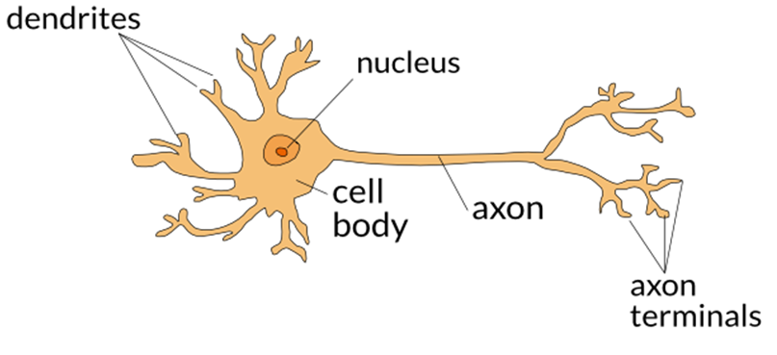

Figure 1. A biological neuron.

* 1. BIOLOGICAL NEURAL NETWORKS.

Despite individual neurons seeming simple, they form intricate networks, with each neuron typically connected to thousands of others. These networks perform highly complex computations, akin to the emergent complexity of an anthill from simple ants. Research on biological neural networks (BNNs), especially in the cerebral cortex, reveals layers of organization, aiding in understanding brain function.

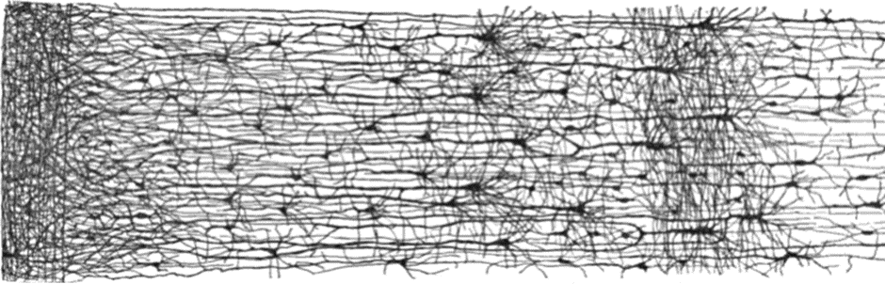

Figure 2. Human cortex.

* 1. ARTIFICIAL NEURONS.

Artificial neurons, invented by Frank Rosenblatt in 1957, are one of the simplest structures of artificial neural networks (ANNs). They are based on a type of artificial neuron called a threshold logic unit (TLU) or linear threshold unit (LTU). A perceptron consists of three components: input (which undergoes linear function computation), multiplication (where the computation is performed), and output (resulting in the final output). They can be used for binary classification by outputting one class if the computed value exceeds a threshold, and the other class otherwise.

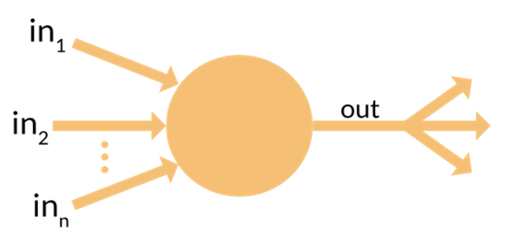

Figure 3. Components of Artificial neurons.

* 1. ARTIFICIAL NEURAL NETWORKS.

Artificial Neural Networks (ANNs) are computational models inspired by the way biological neural networks operate in animal brains. ANNs consist of a collection of artificial "neurons" organized into layers, with connections between neurons weighted. Information is propagated through the network by computing the output values of neurons based on the linear combination of input values and connection weights, followed by the application of an activation function to generate the neuron's output.

ANNs have the ability to learn from data through the process of adjusting the connection weights between neurons, based on comparing predicted outputs with actual outputs. ANN models can be used to perform various tasks, including classification, prediction, recognition, and control, and have been widely applied across fields such as computer vision, natural language processing, and autonomous driving.

* 1. OUTPUT OF AN ARTIFICIAL NEURON.

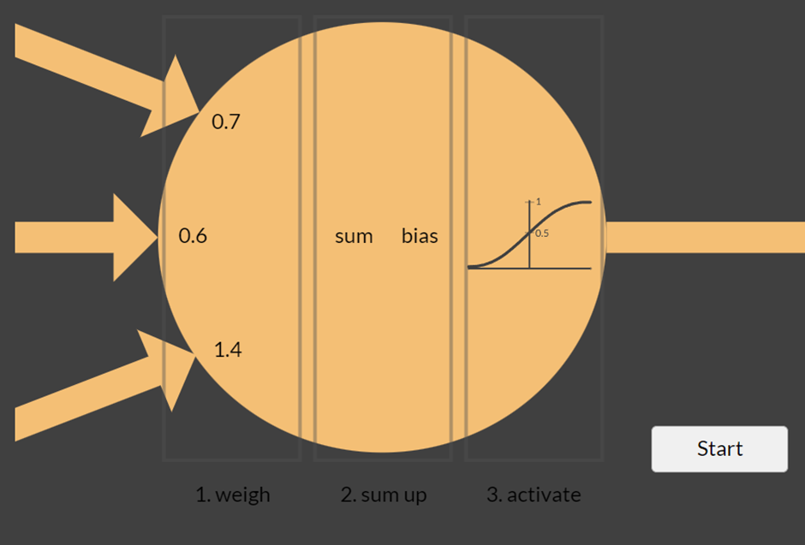

Figure 4. Three processing steps of calculations inside a neuron.

* + 1. Each input gets scaled up or down

When a signal comes in, it gets multiplied by a weight value that is assigned to this particular input. That is, if a neuron has three inputs, then it has three weights that can be adjusted individually. During the learning phase, the neural network can adjust the weights based on the error of the last test result.

* + 1. All signals are summed up

In the next step, the modified input signals are summed up to a single value. In this step, an offset is also added to the sum. This offset is called bias. The neural network also adjusts the bias during the learning phase.

This is where the magic happens! At the start, all the neurons have random weights and random biases. After each learning iteration, weights and biases are gradually shifted so that the next result is a bit closer to the desired output. This way, the neural network gradually moves towards a state where the desired patterns are “learned”.

* + 1. Activation

Finally, the result of the neuron’s calculation is turned into an output signal. This is done by feeding the result to an activation function (also called transfer function).

* + 1. Activation functions

Activation functions are functions applied to the output of each neuron in a neural network to produce a non-linear output. These functions help neural networks learn and understand complex patterns by addressing the issue of chaining linear transformations.

When linear transformations are chained together, the result is still a linear transformation, which fails to introduce diversity or complexity into the output. This diminishes the neural network's performance in learning complex patterns. Therefore, to enable neural networks to learn complex patterns, we need to apply activation functions to create non-linearities between layers, making the neural network more powerful and flexible in solving complex problems.

* + 1. Forward propagation and Backpropagation
       1. Vectors, matrices, and matrix multiplication

In mathematics, a matrix is a data structure that can be represented as a two-dimensional array of numerical elements, denoted by various numbers or expressions. Each element in the matrix is located by specifying its corresponding row and column in the array.

Vector is a one-dimensional network

Matrix multiplication is an operation in linear algebra where two or more matrices are combined to create a new matrix. Matrix multiplication is performed by multiplying the elements of the rows of the first matrix by the elements of the columns of the second matrix, and then summing up these products. To multiply two matrices A and B, the number of columns in matrix A must be equal to the number of rows in matrix B. The result of matrix multiplication has dimensions equal to the number of rows of the first matrix and the number of columns of the second matrix.

* + - 1. Output of a neuron (vectorized form)

**h(x)=ϕ(xw+b)**

x: vector ([x1, x2, x3])

w: weigh ([w1, w2, w3])

b: bias

h: output

ϕ: function takes a number and returns a number

* + - 1. Forward propagation (Prediction of neural networks)

Forward propagation is the process of transmitting computations from the input of a neural network through its layers to generate predicted outputs. During this process, input values are passed through each layer of the network, with each layer performing calculations and forwarding them to the next layer. Calculations typically involve the dot product of weights with inputs, addition of biases, and application of activation functions.

Forward propagation is commonly performed to compute the output of a neural network based on input data, which is then used to compute errors and update weights during the network training process.

* + - 1. Backpropagation (Training neural networks)

To get the parameters, we must go through the training process. The training process is called Backpropagation.

Different parameters (weights and bias) lead to given training data, we try to find parameters that give the most (most correct prediction).

Backpropagation algorithm:

+ Initialize parameters (must be random values)

+ Repeat until convergence:

* Make predictions (Forward propagation) of training instances.
* Compute error (subtraction, root of two or absolute value) or loss.
* Update parameters to reduce the error.

Computing error:

+ Popular loss functions:

* Mean squared error
* Mean absolute error
* Huber loss (combines MSE and MAE):

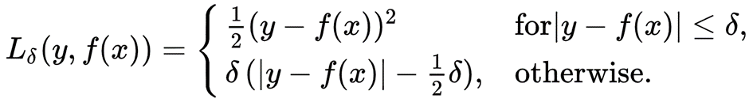

Updating parameters:

+ Compute the gradient of the network’s error w.r.t. each parameter.

+ Update parameters using the gradient descent formula.

* + 1. Using NNs

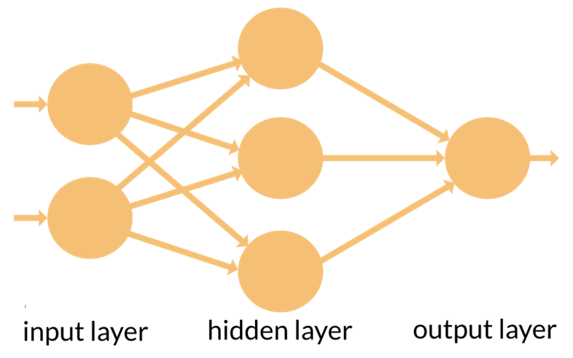

Figure 5. NNs.

- The number of neurons in the input must be equal to the number of inputs

- Hidden layer depends on the problem

- Output depends on demand

- NNs for regression:

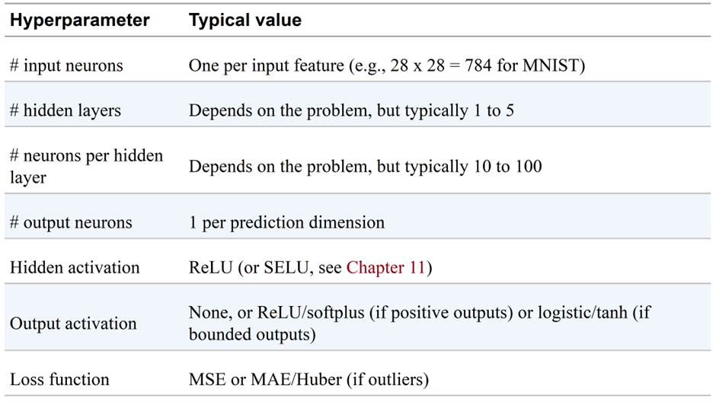

Figure 6. Typical regression MLP architecture.

NNs for classification:

+ Recall:

* Binary classification: return a number
* Multiclass classification: return a number
* Multilabel classification: return a vector (vector includes binary)
* Multioutput classification: return a vector

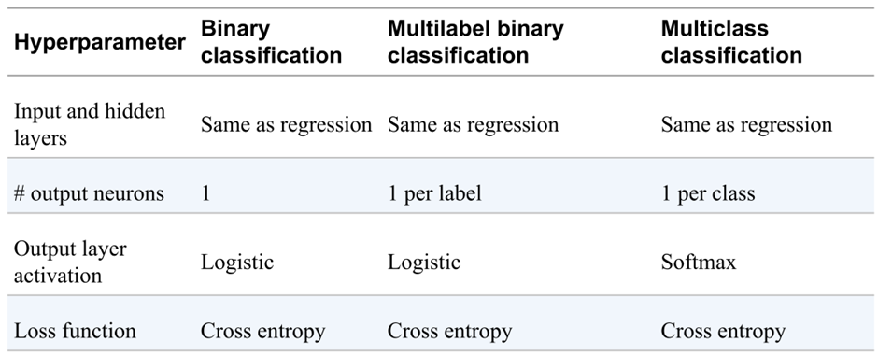

Figure 7. Typical classification MLP architecture.

CHAPTER 3: INTRODUCTION TO ANNS

1. 1. BUILD YOUR FIRST NNS USING SEQUENTIAL API

- Corresponds to the Feed Forward neural network

- Loss functions:

+ Sparse_categorical_crossentropy: Multiclass classification

+ Categorical_crossentropy: Multilabel classification

+ Binary_crossentropy: Binary classification

- An epoch is a complete loop through the entire training data

- Hyperparameter tunning:

+ First, try changing learning rate

+ Try another optimizer

+ Change number of layers, neurons per layer, activation functions, batch size.

* 1. NONSEQUENTIAL NNS - FUNCTIONAL API

- Nonsequential neural networks (NNs) are a type of neural network that does not adhere to a sequential structure. In nonsequential networks, layers are not only arranged in a fixed sequence but may have non-linear connections or non-sequential data patterns.

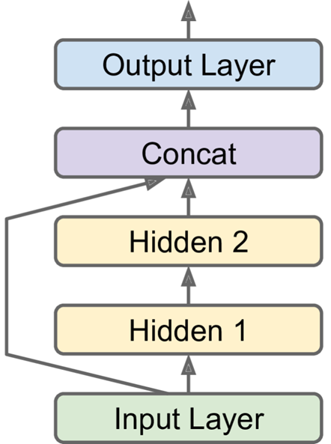

Figure 8. Wide and Deep neural network.

- It connects all or part of the inputs directly to the output layer.

- When data is spread over a large area, information is not lost much.

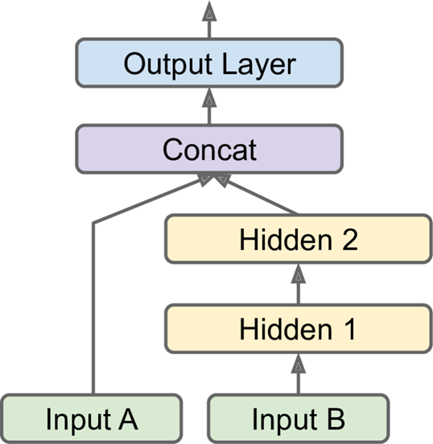

Figure 9. Wide & Deep neural network with multiple inputs.

- Multiple inputs allow sending different subsets of features through different paths in the neural network.

- For example, in a Wide & Deep network, some features may go through a "wide" path for capturing simple relationships, while others go through a "deep" path for learning complex patterns.

- The code demonstrates how to create a model with multiple inputs in Keras and how to compile and fit the model using separate input matrices for each input.

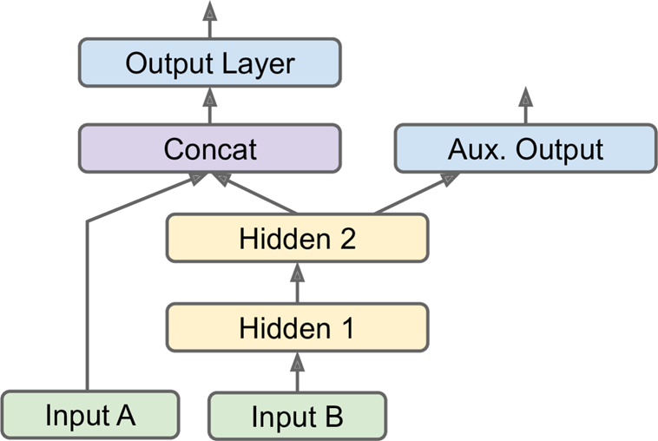

Figure 10. Wide & Deep neural network with multiple inputs.

- Multiple outputs are useful for tasks such as multitask learning or regularization.

- Examples include locating and classifying objects in images, or adding auxiliary outputs to ensure certain parts of the network learn useful features independently.

- The code illustrates how to add multiple outputs to a model in Keras, including defining separate loss functions for each output and setting loss weights to balance their contributions during training.

* 1. SUBCLASSING API
     1. Static models

- A static model is a static graph of layers

- Declarative. Keras APIs: Sequential, Functional

- Advantages:

+ Ease of use for common architectures.

+ Facilitates static analysis of the model's structure.

+ Enables easy debugging due to the static graph nature.

- Disadvantages:

+ Lack of support for dynamic behaviors like loops or conditional branching.

+ Hidden model architecture makes it harder for Keras to inspect, save, clone, or check types and shapes ahead of time.

* + 1. Dynamic models

- Advantages:

+ Suitable for models with dynamic behaviors or researchers experimenting with new ideas.

+ Provides flexibility to implement complex architectures or custom behaviors.

- Disadvantages:

+ Hidden model architecture within the call() method makes it harder for Keras to inspect, save, clone, or check types and shapes ahead of time.

- Keras implementation:

+ Subclass the Model class

+ Create the layers in the constructor

+ Perform the computations in the call() method

* 1. CALLBACKS

- A callback is an object that can perform actions at various stages of training

- Examples of callbacks:

+ ModelCheckpoint: saves models while training.

+ EarlyStopping: stops training when there is no improvement on val_loss for a number of epochs.

+ TensorBoard: view the learning curves during training, analyze training statistics, view images generated by your model, and more.

+ Custom Callbacks: allows you to define custom behavior at various points during training, such as at the start or end of epochs or batches.

* 1. HYPERPARAMETER TUNING
     1. NN’s hyperparameter

Neural network hyperparameters refer to the configurable settings or parameters that are not learned by the model during training but directly affect its performance, training time, and generalization ability.

* + 1. Number of Hidden layers

- For simple problems, like basic classification tasks, a single hidden layer can often suffice.

- For more complex problems, using multiple hidden layers can yield much better performance compared to having just one layer with many neurons.

- For very complex tasks, such as deep learning for image recognition or natural language processing, it may be necessary to use hundreds of layers and a vast amount of training data.

- Two common methods for structuring hidden layers are:

+ Starting with later layers having fewer neurons, resembling a pyramid.

+ Using the same number of neurons in all hidden layers.

- In practice, it's often effective to gradually increase the number of neurons and layers until the model begins to overfit. Additionally, it's common to pick a model with more layers and neurons than needed and then apply techniques like early stopping and regularization to prevent overfitting.

* + 1. Other hyperparameters

- Learning Rate:

+ The learning rate is a crucial hyperparameter in training neural networks.

+ Typically, the optimal learning rate is about half the maximum rate that allows convergence (found through experiments where the learning rate is gradually increased).

+ A practical method to determine a good learning rate is to start with a very low value and increase it exponentially until the loss begins to increase, then set the learning rate to about a tenth of this value.

+ Adjustments may be needed if other hyperparameters are changed.

- Optimizer:

+ Choosing an effective optimizer can significantly influence the model's performance.

+ Advanced optimizers often outperform basic mini-batch gradient descent, as they can handle issues like varying learning rates or adapting the learning rate based on the training dynamics.

+ Details and comparisons of different optimizers are explored further in specialized chapters, advocating for choosing the right optimizer based on specific model requirements and data characteristics.

- Batch size: can have a significant impact on your model’s performance and training time.

+ Strategy 1: using small batches (from 2 to 32) was preferable

+ Strategy 2: uses a large batch size (up to 8192) with increasing learning rate

- Activation Function:

+ The choice of activation function is crucial for the performance of neural networks.

+ ReLU (Rectified Linear Unit) activation function is commonly used in hidden layers due to its simplicity and effectiveness in alleviating the vanishing gradient problem.

+ For the output layer, the choice of activation function depends on the specific task being addressed.

- Number of Iterations:

+ The number of training iterations, or epochs, determines how many times the entire dataset is passed forward and backward through the network during training.

+ In many cases, the number of iterations does not need to be manually tweaked, as early stopping can be used to halt training when performance on a validation set stops improving.

+ Early stopping is a more practical approach to prevent overfitting and optimize training time, rather than manually adjusting the number of iterations.

* + 1. Libraries for NN hyperparameter tuning

- GridSearchCV or RandomizedSearchCV (see section Fine-Tuning Neural Network Hyperparameters in chapter 10, (Géron, 2019))

- Hyperopt

- Keras Tuner

- Scikit-Optimize (skopt)

- Hyperband

- Sklearn-Deap

- AutoML

- Services for hyperparameter optimization services by companies

CHAPTER 4: TRAINING DEEP NEURAL NETWORKS

1. 1. SHALLOW VS DEEP NNS

Shallow nets:

- Shallow nets have a small number of hidden layers between the input and output layers. They typically contain only one or two hidden layers, making them relatively simple in structure. Due to their limited depth, shallow networks may struggle to capture complex relationships in data that require multiple levels of abstraction.

- Shallow networks are generally used for simpler tasks where the data has low complexity and can be effectively represented by a small number of features.

Deep nets:

+ Advantage: can solve very complex problems

+ Problems:

* Vanishing / exploding gradients:
* Not have enough training data, or might be too costly to label.
* Training may take so long.
* Risk of severely overfitting the training set.
  1. VANISHING/EXPLODING GRADIENTS PROBLEMS

Vanishing gradients: the gradients grow smaller and smaller.

Exploding gradients: the gradients grow.

Unstable gradients: different layers may learn at widely different speeds.

One reason of vanishing gradients: combination of sigmoid activation function and the weight initialization technique.

* 1. SOLUTIONS FOR THE GRADIENT PROBLEMS

- For sigmoid activation, *Glorot initialization* (Glorot & Bengio, 2010): weights of each layer must be initialized randomly using

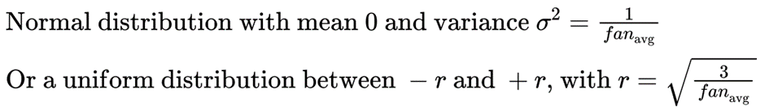

- Glorot initialization can address the unstable gradients problem and speed up training considerably

- Initialization startegies:

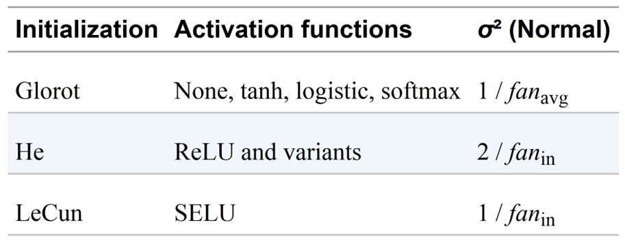

Figure 11.Initialization parameters for each type of activation function.

* 1. KERAS IMPLEMENTATION

- By default, Keras uses Glorot initialization with a uniform distribution.

- When creating a layer, you can change this to He initialization by setting

kernel_initializer="he_uniform" or

kernel_initializer="he_normal" like this:

keras.layers.Dense(10, activation="relu", kernel_initializer="he_normal")

* 1. ACTIVATION FUNCTIONS

- ReLU (Rectified Linear Unit):

+ Pros: Fast computation, does not saturate for positive values.

+ Cons: May suffer from dying ReLUs, where some neurons cease to activate during training.

+ Solution: Leaky ReLU, which introduces a small slope for negative inputs to prevent dying ReLUs.

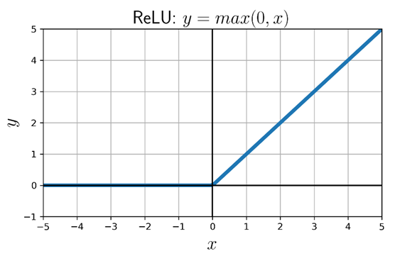

Figure 12. ReLU

- Leaky ReLU:

+ Pros: Addresses dying ReLUs by allowing a small, non-zero gradient for negative inputs.

+ Cons: May not completely prevent neurons from deactivating in some cases.

+ Variants: Randomized Leaky ReLU (RReLU), Parametric Leaky ReLU (PReLU).  
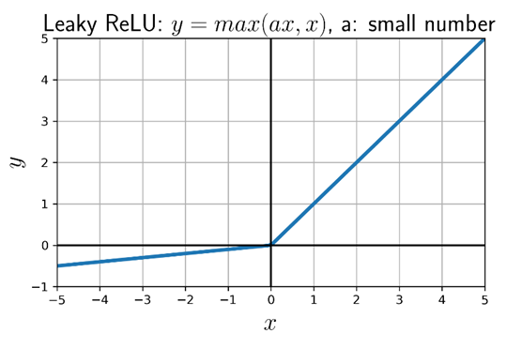

Figure 13. Leaky ReLU.

- ELU (Exponential Linear Unit):

+ Pros: Smooth function with a non-zero gradient for negative inputs, helping to mitigate vanishing gradients.

+ Cons: Slower computation compared to ReLU due to the use of the exponential function.

+ Offers a faster convergence rate during training.

+ Exponential linear unit (**ELU**): outperformed all the ReLU variants.

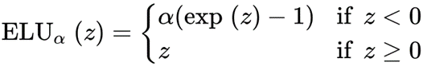

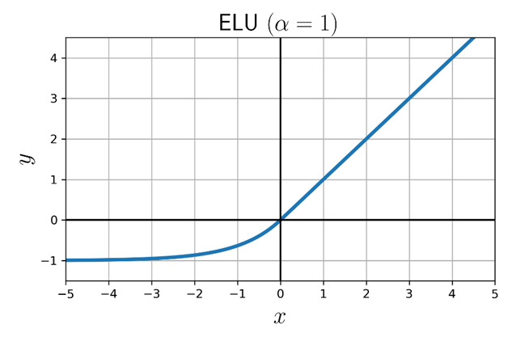

Figure 4-4.ELU

- SELU (Scaled ELU):

+ Scaled ELU (SELU): significantly outperforms other activation functions, with conditions:

* Input features must be standardized (mean 0 and standard deviation 1).
* Weights must be initialized with LeCun normal initialization.
* The network’s architecture must be sequential.

SELU_𝛼 (𝑥)=𝑠𝑐𝑎𝑙𝑒×ELU_𝛼 (𝑥)  
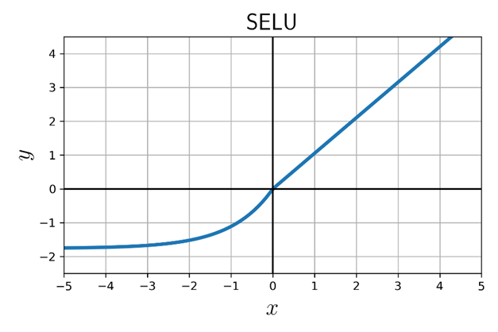

* 1. TIP AND IMPLEMENTATION

Evaluation of accuracy and speed: **SELU > ELU > leaky ReLU > ReLU > tanh > sigmoid**

Keras implementation:

SELU: keras.layers.Dense(10, activation="selu", kernel_initializer="lecun_normal")

Leaky ReLU: keras.layers.Dense(10, kernel_initializer="he_normal"),

keras.layers.LeakyReLU(alpha=0.2),

* 1. BATH NORMALIZATION

**-** Vanishing/Exploding Gradients Problems:

+ The danger of vanishing or exploding gradients at the beginning of training can still exist even with He initialization and ELU or ReLU activation functions.

+ Sergey Ioffe and Christian Szegedy proposed Batch Normalization (BN) in a 2015 paper as a technique to address these issues.

+ Batch Normalization involves adding an operation before or after the activation function of each hidden layer.

+ This operation standardizes inputs by zero-centering and normalizing them, then scales and shifts the result using learned parameters.

+ During training, BN computes the mean and standard deviation of each input over the current mini-batch.

+ At test time, BN estimates statistics using a moving average of the input means and standard deviations computed during training.

+ BN improves deep neural networks by reducing the vanishing gradients problem, allowing the use of saturating activation functions like tanh or logistic, and making networks less sensitive to weight initialization.

+ It enables the use of larger learning rates, accelerates the learning process, and improves model accuracy, as demonstrated on tasks like ImageNet classification.

+ Additionally, Batch Normalization acts as a regularizer, reducing the need for other regularization techniques like dropout.

- Pros:

+ Vanishing gradients problem

+ Weight initialization

+ Add BN after input layer 🡪 feature scaling

+ BN acts like

=> For deep networks

- Cons:

+ Add some complexity to the model 🡪 each epoch takes

- Implementing BN with Keras: keras.layers.BatchNormalization()

Note: since a BN layer includes 1 offset parameter per input.

* 1. GRADIENT CLIPPING

- Gradient clipping is a technique used to address the issue of exploding gradients during neural network training, especially in recurrent neural networks (RNNs). It involves setting a threshold value, beyond which gradients are scaled down to prevent them from exceeding this threshold during backpropagation.

- Implementing in Keras:

+ You can implement gradient clipping by setting the clipvalue or clipnorm argument in the optimizer.

* optimizer = keras.optimizers.SGD(**clipvalue=1.0**)
* optimizer = keras.optimizers.SGD(**clipnorm=1.0**)

- Adaptive gradient clipping (AGC)

+ Addressing Gradient Instability: AGC, or Adaptive Gradient Clipping, dynamically adjusts the clipping threshold during neural network training to prevent exploding gradients, thereby promoting stability and efficient convergence.

+ Replacement for Batch Normalization (BN): AGC can serve as an alternative to Batch Normalization, especially in scenarios where BN is impractical, such as when using dropout techniques or the Sharpness-Aware Minimization (SAM) optimizer with modifications.

+ Compatibility with Dropout: AGC is compatible with dropout techniques, allowing it to be seamlessly integrated into neural network architectures where dropout is used for regularization purposes.

+ Integration with SAM Optimizer: With appropriate modifications, AGC can complement the Sharpness-Aware Minimization (SAM) optimizer, providing an effective approach for gradient clipping while leveraging the benefits of SAM for optimization tasks.

+ In essence, AGC offers a flexible and adaptive solution for mitigating gradient instability in neural network training, suitable for various architectures and optimization techniques, including those where Batch Normalization may not be suitable.

* 1. USING PRETRAINED LAYERS

- Training Large DNNs:

+ Begin by finding an existing neural network (NN) that has been trained on a similar task.

+ Reuse the lower layers and other parameters of this network. This approach not only accelerates training considerably but also reduces the amount of training data required.

- Deep NNs Properties:

+ Lower Hidden Layers: These layers capture low-level features and patterns in the input data.

+ Intermediate Hidden Layers: These layers progressively abstract higher-level features and representations from the input.

+ And so on: Deeper layers typically encode more abstract and complex features.

- Transfer Learning:

+ Example 1: Suppose a model has already been trained to recognize faces. Now, a new NN is needed to recognize specific facial attributes or emotions.

+ Example 2: Consider a DNN that has been trained to classify images into 100 categories (e.g., animals, plants, vehicles). Now, a new DNN is required to classify specific types of vehicles.

* 1. LEARNING RATE SCHEDULING

This is an important technique in the neural network training process to optimize learning performance. It involves adjusting the model's learning rate over time (epoch or iteration) during training.

* 1. LEARNING CURVE.

The y-axis graph is loss measuring performance, the x-axis is the number of iterations or training time. If you set it too low, training will eventually converge to the optimum, but it will take a very long time. If you set it slightly too high, it will make progress very quickly at first, but it will end up dancing around the optimum, never really settling down.

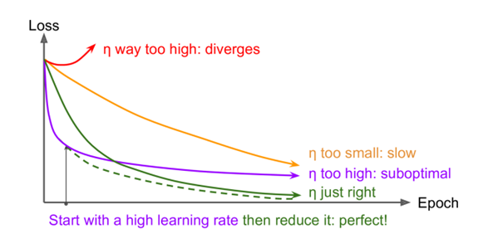

Figure: Learning curves for various learning rate η

There are many different strategies to reduce the learning rate during training. It can also be beneficial to start with a low learning rate, increase it, then drop it again. These strategies are called learning schedules. These are the most commonly used learning schedules:

* + 1. Time-based decay scheduling

**Definition:** This method will cause the model's learning rate to gradually decrease over time during the training process

**How it works:** The initial learning rate is set to a certain value, after each epoch or certain period of time, the learning rate will decrease according to the formula.

**n(i)=n0/(1+d x i)**

n0 : The initial learning rate

d: the decay factor (a small positive number)

i: Time for learning

n(i): learning rate at i

Example:

We have n0=0.1 and decay=0.01. After 10 epoch, the learning rate will be calculated as:

N(10)= 0.1/(1+ 0.01 * 10)= 0.0909

**Implementing in Keras:**

Optimizer = keras.optimizer.SGD(lr=0.01, decay=1e-3)

* + 1. Exponential scheduling

**Definition:** This method causes the model’s learning rate to decrease exponential during the training process

**How it works:** The initial learning rate is set to a certain value, after each epoch or certain period of time, the learning rate will be gradually reduced in an exponential function with a predetermined decay rate.

n(i)= n0 x di/s

n0: the initial learning rate

d: decay rate

s: decay step

i: time/ epoch

**Example:**

If we set up n0= 0.1 and d= 0.01. After 10 epoch, learning rate will be calculated as:

n10= 0.1* 0.0110/1

**Implementing in keras:**

Lr_schedule= tf.keras.optimizer.schedules.ExponentialDecay(initial_learning_rate=0.1, decay_rate=0.9, decay_steps=10000)

Optimizer= tf.keras.optimizer.SGD(learning_rate=lr_schedule)

**Advantages:**

- Prevent overfitting

- Accelerate convergence

- Flexible

- Little dependence on parameter values

**Disadvantages:**

- Difficult to choose parameters

- Learning rate decreases rapidly in some case

* + 1. Piecewise constant scheduling

**Definition:** In this method, the learning rate will be kept stable for a certain period of time, then will be changed to another constant value at breakpoints between segments.

**How it works**: Use a constant learning rate for a number of epochs (e.g., η = 0.1 for 5 epochs), then a smaller learning rate for another number of epochs (e.g., η = 0.001 for 50 epochs), and so on.

**Example:**

Suppose you set up a piecewise constant scheduling schedule with 3 segments:

Episode 1 (epoch 1-5): Learning rate = 0.1

Passage 2 (epoch 6-10): Learning rate = 0.01

Passage 3 (epoch 11-onwards): Learning rate = 0.001

During the first 5 epochs, the model's learning rate will always be 0.1. After the 5th epoch, upon reaching the first transition point, the learning rate will decrease to 0.01 and remain so until the 10th epoch. Similarly, after the 10th epoch, the learning rate will further decrease to 0.001 and maintain this value for the remainder of the training process.

**Implementing to keras:**

Lr_schedule=tf.keras.optimizers.schedules.PiecewiseConstantDecay(boundaries=[10000,11000], values=[0.1,0.5,0.1])

Optimizer= tf.keras.optimizers.Adam(learning_rate=lr_schedule)

**Advantages:**

-Flexible control

-Prevent overfitting

-Customizable for each model

**Disadvantages:**

-More complicated

-Not optimal in some situation

* + 1. Performance scheduling

**Definition**: similar to piece constant scheduling, but the learning rate are decided by performance

**How it works:** Measure the validation error every N steps (just like for early stopping), and reduce the learning rate by a factor of λ when the error stops dropping

**Implementing to keras:**

Lr_scheduler= keras.callbacks.ReduceLROnPlateau(factor=0.5, patience=5)

**Advantages:**

- Optimize performance

- Energy saving

**Disadvantages:**

- Complicate

* + 1. 1 cycle scheduling

**Definition:** 1-cycle scheduling uses a cosine function to adjust the model's learning rate over time during a training cycle.

**How it works:**

There are 3 steps in 1 cycle:

- Step 1. Starts by increasing the initial learning rate n0 linearly up to nM halfway through training.

- Step 2. Then decrease the learning rate linearly down to n0 again during the second half of training

- Step 3. Finishes the last few epochs by linearly dropping the rate down by several orders of magnitude

nt=nmin + (nmax –nmin ) * (1+ cos(pi*t/T))/2

nt: learning rate at t

nmin: minimum learning rate

nmax: maximum learning rate

t: epoch

**Example:**

If we have 1 cycle with parameters:

nmin=0.001

nmax=0.1

T=100

nt=0.001 + (0.1 –0.001) * (1+ cos(pi*t/100))/2

**Advantages**

- Simple

- Effective

- Easy to adjust

**Disadvantages:**

- May be problematic for large models

- Not suitable for all models

* 1. Comparison learning schedules

Table 1. Comparison learning schedules.

|  |  |  |
| --- | --- | --- |
| **Learning rate scheduling** | **Speed** | **Effective** |
| Time-based decay scheduling | Slow | Average |
| Exponential scheduling | Average | High |
| Piecewise constant scheduling | Fast | Average |
| Performance scheduling | Fast | High |
| 1-cycle scheduling | Average | High |

* 1. Regularization

Technique used to reduce overfitting

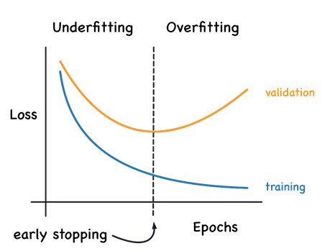

**Figure:** Underfitting and Overfitting

There are some regularization techniques for NNs such as early stoping, batch normalization, l1 and l2 regularization, max-norm regularization, and dropout.

* + 1. L1 and l2 regularization

**Define:** This technique adds another quantity to the model's loss function based on the L1 norm (sum of absolute values) and L2 norm (sum of squares) of the weights in the model. This technique helps prevent the model from having too many large weights, promotes sparsity, and reduces model complexity.

L1: regularization: (Least Absolute Shrinkage and Selection Operator)

Loss_L1 = Loss_base + λ * Σ |w_i|

Loss_base: Original loss function of the model

λ : The hyperparameter adjusts the influence of L1 Regularization

w_i: model weight at position i

|w_i|: Absolute value of weight

L2: Regularization (Ridge Regression)

Loss_L2 = Loss_base + λ * Σ w_i^2

Loss_base: Original loss function of the model

λ : The hyperparameter adjusts the influence of L1 Regularization

w_i: model weight at position i

w_i^2: Square of weight

**Implement:**



For L1 regularization: keras.regularizers.l1(alpha1)

For L2 regularization: keras.regularizers.l1_l2(alpha1, alpha2)

**Advantages:**

-Stable

-Effective

-Easy to setup

-Can create sparsity

**Disadvantages:**

-Need to choose the appropriate level of regularization

* + 1. Dropout:

**Define:** Dropout is a technique that helps avoid overfitting similar to regularization by removing random p% nodes of the layer and then this forces the model to learn redundant representations and prevents it from relying too heavily on any particular neuron or feature. This helps make the model less complicated (p belongs to [0.2, 0.5]). A p% is call dropout rate and is around 10% to 50%.

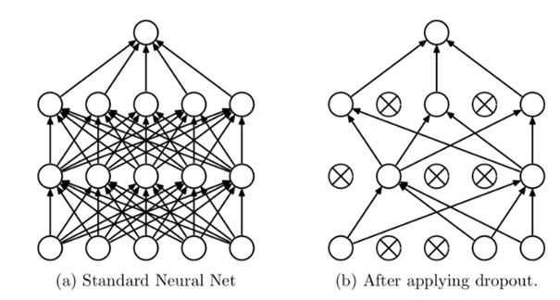

Figure 14. Standard Neural Network and Dropout.

**Implement:**

To implement dropout using keras, you can use the keras.layers.Dropout layers

Keras.layer.Dropout(rate=0.2)

Example: The following code applies dropout regularization before every Dense layer, using a dropout rate of 0.2:

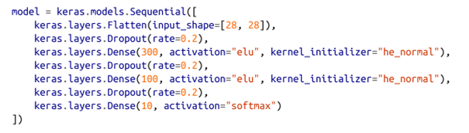

**Advantages:**

- Effective

- Easy to setup

- Apply to many models

**Disadvantages:**

- Need to choose the appropriate level of dropout

* + 1. Max-norm regularization

**Define:** This is a technique that targets model complexity and solves the overfitting phenomenon. Max-norm regularization works by limiting the absolute value of the weights in the model below a certain threshold. For each neuron, it scales it weight vector by w= w/ ||w||2 to force the l2-norm of the neuron’s weights ||w||2<r then it will reduce r helps. Reducing r increases the amount of regularization and helps reduce overfitting.

**Implement:**

To implement max-norm regularization in Keras:



**Advantages:**

- Prevent v exploding

- Simple

- Easy to setup

**Disadvantages:**

- Slow down the training process

* 1. Comparision regularization techniques

Table 2. Comparision regularizationn techniques.

|  |  |  |  |  |
| --- | --- | --- | --- | --- |
| **Criterion** | **Dropout** | **L1 Regularization** | **L2 Regularization** | **Max-norm Regularization** |
| Effectiveness in Preventing Overfitting | Effective | Effective | Effective | Effective |
| Complexity | Simple | Moderate | Moderate | Moderate |
| Ease of Implementation | Easy | Easy | Easy | Easy |
| Computational Efficiency | Efficient | Efficient | Efficient | Efficient |
| Can Induce Sparsity | No | Yes | No | No |
| Stability | Moderate | Moderate | High | High |
| Sensitivity to Noise | High | Moderate | Low | Low |
| Requires Tuning of Rate/Strength | Yes | Yes | Yes | Yes |
| Can Reduce Model Performance | Yes | Yes | Yes | Yes |
| Suitable for | Wide range of models | Models with many features | Wide range of models | Models with many parameters |

CHAPTER 5: PREPROCESSING DATA WITH TENSORFLOW

1. 1. Preprocessing
      1. Definition

Preprocessing data is an important step in machine learning and deep learning. The purpose of this process is to transform raw data into a format that computers can understand and to correct errors and clean raw data before applying it to main algorithms. In addition, preprocessing data also plays a role. plays an important role in developing the performance as well as the accuracy of algorithms when included in the project.

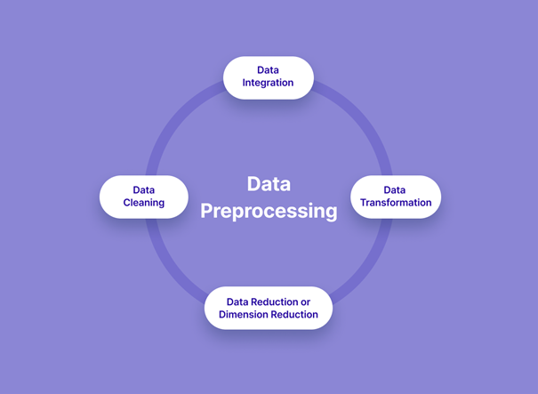

Figure 15. Data preprocessing.

* + 1. How it works

Normally a data preprocessing process will include steps

- Data cleaning:  the data can have many irrelevant and missing parts then this data cleaning phase will handle missing data and noisy data. To handle missing data, we can ignore the tuples and fill the missing values, and noisy data can be handled in various ways such as the binning method, regression, and clustering

- Data integration: is the process of combining heterogeneous data from many different sources into a unified data set

- Data transformation: this step will help to transform the data in appropriate forms suitable for certain models. This involves the following ways: normalization, attribute selection, discretization and concept hierarchy generation.

- Data reduction or dimension reduction: this is a crucial step in preprocessing data, this will reduce the size of the dataset and improve the efficiency of data analysis and to avoid overfitting of the model. There are some steps in data reduction such as sampling, clustering, compression, and feature selection.

* 1. Methods

There are various techniques for preprocessing data such as: Numpy, sklearn, pandas dataframe, DataApi, TfRecord, and Tf datasets.

* + 1. DataApi

**Definition:** this is a powerfull toolset for handling data efficiently, especially suited for deep learning workflow since deep Learning systems are often trained on very large datasets that will not fit in RAM. DataApi DataApi makes processing large data sets more efficient and smooth.

**How it works:** You just create a dataset object, and tell it where to get the data and how to transform it and then dataApi will load data from various sources like CSV files, NumPy arrays, or TFRecords. TensorFlow takes care of all the implementation details, such as multithreading, queuing, batching, and prefetching. It also provides functions to define how data is read and parsed. There are several methods for preprocessing data after you get data from DataApi.

* + 1. Chaining Transformations

**Definition:** Once you have a dataset, you can apply all sorts of transformations to it by calling its transformation methods. Each method returns a new dataset, so you can chain transformations like this.

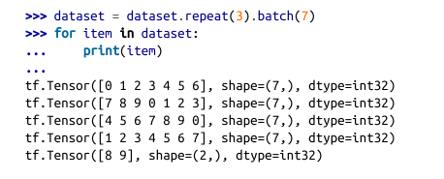

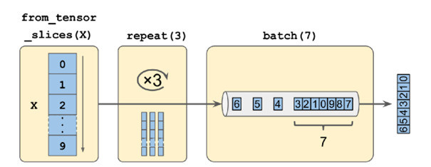

Figure 16 Chaining dataset transformation

Here in this example, we will use the iterate method, iterate 3 times on the original dataset and return the new dataset. Then we call the batch method on this new dataset and it will create a new dataset. However, the size of the final data set is only 2 instead of 7. Therefore, this method does not modify the data set, it creates a new data set.

Dataset= dataset.repeat(3).batch(5)

Additionally, if you want to only process 1 batch at a time instead of combining into multiple batches, you can use the unbatch() function to separate the batches.

Dataset= dataset.unbatch()

Then to transform the data we can use the map() function, and the input of the map function will be a sample and the output will also be a sample.

Dataset= dataset.map( lambda sample: sample*10 if sample<60 else sample, num_parallel_calls=4 )

However, there are cases where we need to transform the entire data. There will be cases where the data has empty spaces, then we will fill in the gaps using the apply function because the map function cannot handle it. on all data. And the input of the apply function is a dataset and the output is the same.

dataset = dataset.apply(lambda datset: datset.filter(lambda sample: sample<max_val))

* + 1. Shuffling the Data

**Definition:** This is the technique of rearranging data samples in your data set in random order. In other words, it reorders the rows (or observations) in your data table to break any preexisting order.

**How it works:**

It will create a new dataset that will start by filling up a buffer with the first items of the source dataset. Then, whenever it is asked for an item, it will pull one out randomly from the buffer and replace it with a fresh one from the source dataset, until it has iterated entirely through the source dataset. At this point it continues to pull out items randomly from the buffer until it is empty.

**Example:**

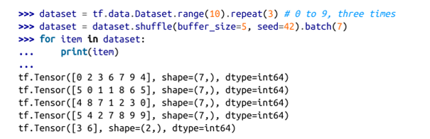

In this example, the following code creates and displays a dataset containing the integers 0 to 9, repeated 3 times, shuffled using a buffer of size 5 and a random seed of 42, and batched with a batch size of 7.

However, for a large data set that cannot fit in memory, this simple cache shuffling method may not be enough because the cache will be smaller than the data set. That's why we have another solution which is to shuffle directly on the hard drive. To shuffle the hard drive, perform the following steps.

Step 1: First, we need a data set to shuffle, here we will use the cali house price data set



Step 2: Next we will simulate the data.

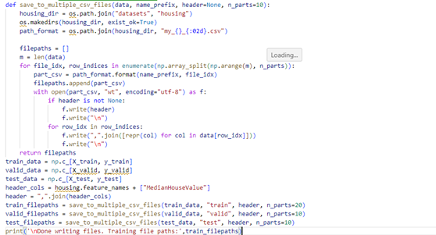

Step 3: Create a dataset containing file paths in RANDOM ORDER, using list_files().

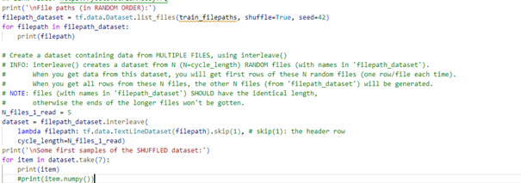

Finally, after we put everything together and have a complete diagram.

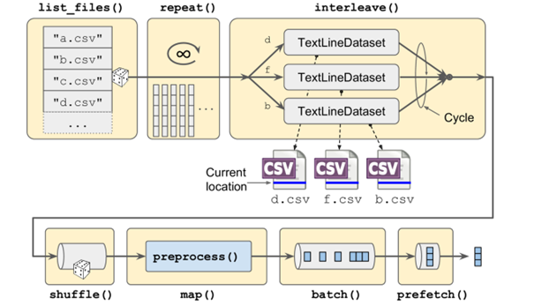

Figure 17 Loading and preprocessing data from multiple CSV files.

it will create and return a dataset that will efficiently load California housing data from multiple CSV files, preprocess it, shuffle it, optionally repeat it, and batch it.

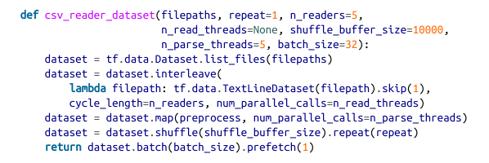

* 1. Prefetching and Multithreading
     1. Prefetching

This is a technique in computer science that downloads data before it is actually needed. The goal is to minimize latency when accessing data and improve overall system performance.

* + 1. Multithreading

This is a technique that allows a program to perform multiple tasks simultaneously. Each task is called a thread, and each thread can be executed independently or in parallel with other threads.

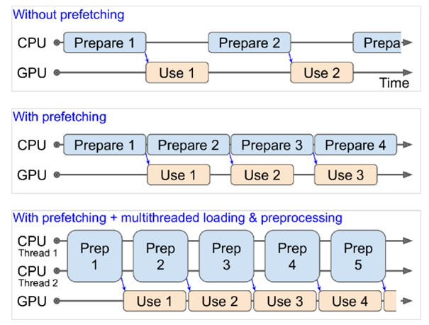

Figure 18 With prefetching, the CPU and the GPU work in parallel: as the GPU works on one batch, the CPU works on the next

* 1. Comparision

|  |  |  |  |
| --- | --- | --- | --- |
| **Feature** | **Prefetching** | **Multithreading** | **Prefetching + Multithreading** |
| Purpose | Load data before it is needed | Execute multiple tasks concurrently | Combine the benefits of Prefetching and Multithreading |
| Benefits | Reduces data access latency, increases bandwidth utilization | Leverages multi-core CPU resources, improves parallel processing capability, reduces response time | Highest efficiency, reduces overall data processing time |
| Drawbacks | Requires accurate prediction of data, consumes memory resources, efficiency depends on prediction | Requires effective thread management, complicates code, efficiency depends on parallelizability | More complex, requires intensive system management |
| Suitable for | Applications that can predict required data, high-bandwidth storage systems | Applications that can be divided into independent tasks, multi-core CPU systems | Applications that require the highest performance, systems with both high-bandwidth storage and multi-core CPUs |
| Example | Prefetching product data for an e-commerce website | Handling multiple HTTP requests concurrently in a web server | Processing image data for a facial recognition application |

* 1. Embedding

**Definition:** Embeddings is a technique in Deep learning that helps change the representation space, helping to represent non-numeric forms (such as text, images, sounds) into lower-dimensional digital vectors. The purpose of embeddings is to minimize data size and capture relationships between data elements.

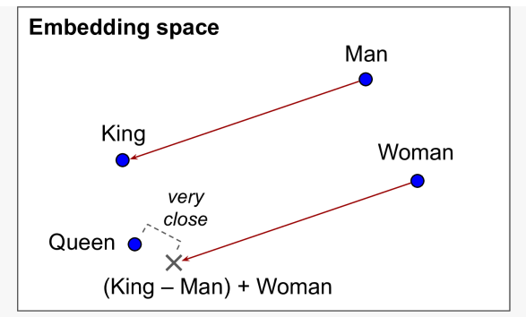

Figure 19 Word embeddings of similar words tend to be close, and some axes seem to encode meaningful concepts.

**Implement:**

Step 1: Randomly initialize embeddings for each category ( when initializing, the size must be specified. The more complex the data, the larger the size)

Step 2: Learn these embeddings during training ( put embeddings in keras.layers.Embedding ) and this keras.layers.Embeddings will automatically connect the input with the output label and learn the embeddings vector to best represent the output.

Example:

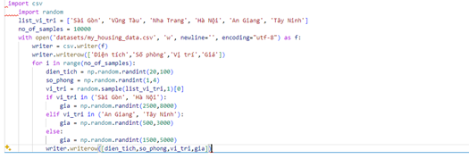

First, we will synthesize data, then load and prepare data

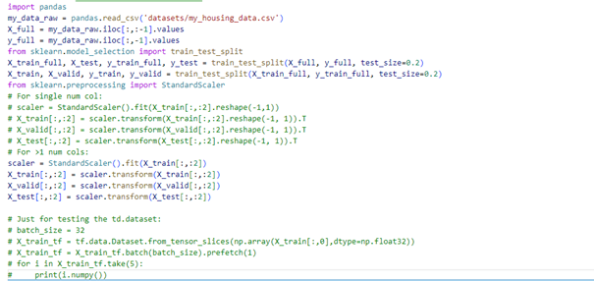

After that we convert categorical feature (position) to integers.

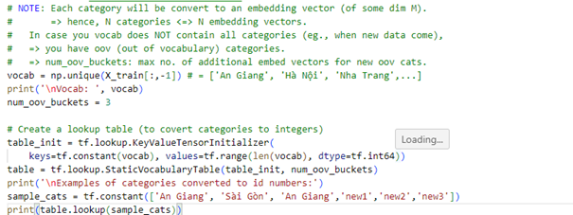

Finally, create an embedding layer

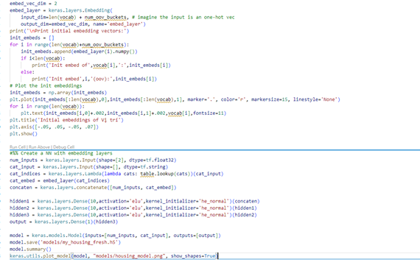

CHAPTER 6: COMPUTER VISION USING CONVOLUTIONAL NEURAL NETWORKS

1. 1. CONVOLUTIONAL NEURAL NETWORKS

**Definition:** This is a type of model used to analyze images and recognize objects. Convolutional neurons differ from regular neural networks in that they can automatically extract important features from image data. This model uses a special technique called convolution.

There are four main operations in a CNN:

- Fully connected layers

- Convolutional layers

- Pooling layers

- Non linearity

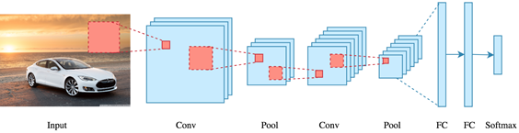

Figure 20. Convolutional neural networks.

* 1. Convolutional layers

The convolutional layer is a core component of convolutional neural networks (CNNs). They are specifically designed to work with grid-structured data, such as images. Dimension of convolutional layers depends on:

- Input size: The input image size of the CNNs network, for convolutional layers, the input size is arbitrary

- Receptive field size: This is the size of the image cell, which can also be called the kernel

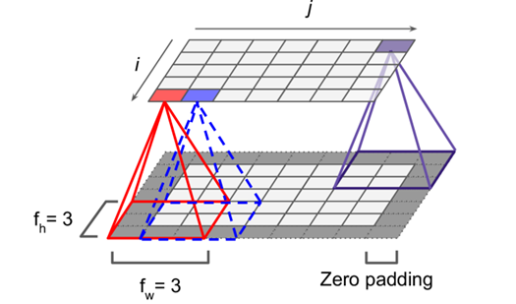

Figure 21. Connections between layers and zero padding.

- Padding: used to expand the edge of the image, to ensure it can identify details close to the edge by adding 0 pixels to expand

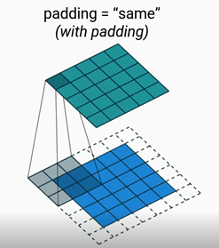

Figure 22. With padding

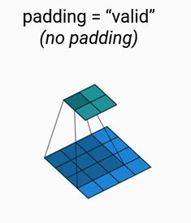

Figure 23. No padding.

Padding = “valid”: Meaning k padding means it can only slide inside the size of the input input

Padding = ”same”: means padding when it can be padded outside the input size

-Stride: Jump, distance once time receptive field slides. The larger the Stride, the larger the output size.

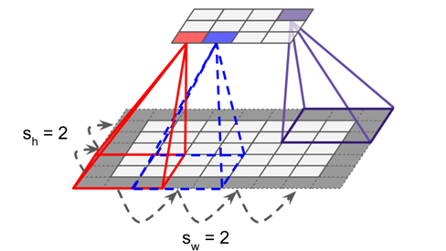

Figure 24. Reducing dimensionality using a stride of 2.

CHAPTER 7: CNN ARCHITECTURES

Some famous CNNs architects.

1. 1. LeNet-5
      1. **Definition**

is a convolutional neural network (CNN) developed by Yann LeCun and colleagues in 1998. This was one of the first CNN models used to solve the problem of handwritten digit recognition and was considered the foundation for many modern CNN models later.

* + 1. Architectures

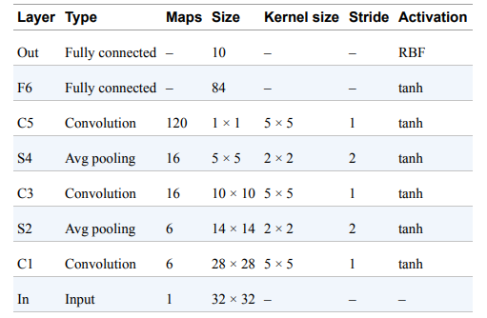

Figure 25 LeNet-5 architecture.

LeNet-5 uses a 7-layer architecture:

Layer 1: Extract basic features from input image

Layer 2: Extract more complex features from images

Layer 3: Reduce data size and retain the most important features

Layer 4: Extracting higher level features from images.

Layer 5: Reduces data size and retains the most important high-level features.

Layer 6: Transform data into feature vectors.

Grade 7: Classify images into one of 10 digits.

* + 1. Advantages

- Simple and effective

- High performance

- Easy to deploy

* + 1. Disadvantages

-Accuracy may be limited.

-Generalizability.

-Fixed size.

* 1. AlexNet
     1. Definition

The AlexNet CNN architecture won the 2012 ImageNet ILSVRC challenge by a large margin. It was developed by Alex Krizhevsky (hence the name), Ilya Sutskever, and Geoffrey Hinton. It is similar to LeNet-5, only much larger and deeper, and it was the first to stack convolutional layers directly on top of one another, instead of stacking a pooling layer on top of each convolutional layer.

* + 1. Architecture

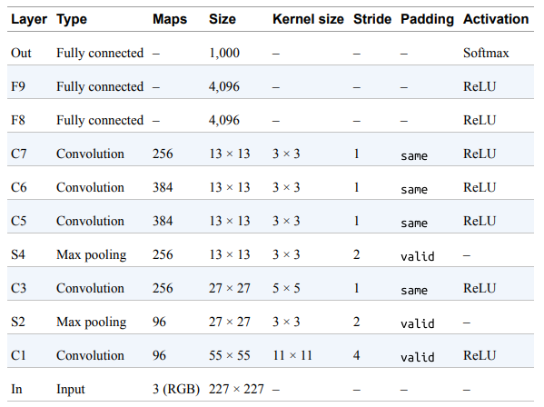

Figure 26 AlexNet architecture.

AlexNet uses 9 layers:

Layer 1: Extract basic features from input image

Layer 2: Extract more complex features from images.

Layer 3: Reduce data size and retain the most important features.

Layer 4: Extracting higher level features from images.

Layer 5: Reduces data size and retains the most important high-level features.

Layer 6: Extracting more abstract features from images.

Layer 7: Reduces data size and retains the most important abstract features.

Layer 8: Transform data into feature vectors.

Grade 9: Classify images into one of 1000 classes.

* + 1. Advantages

- High performance

- Easy to deploy

* + 1. Disadvantages

- Big size

- Requires big data

- Performance may be limited

* 1. GoogleNet
     1. Definition

The GoogLeNet architecture was developed by Christian Szegedy et al. from Google Research, and it won the ILSVRC 2014 challenge by pushing the top-five error rate below 7%.

* + 1. Architectures

GoogleNet uses the Inception architecture. This architecture helps GoogleNet extract image features at many different levels of detail. GoogleNet uses the “1x1 convolutions” technique to reduce the number of parameters in the network, which reduces the risk of overfitting and increases computational efficiency. In addition, GoogleNet also uses multiple parallel processing threads to improve image processing speed.

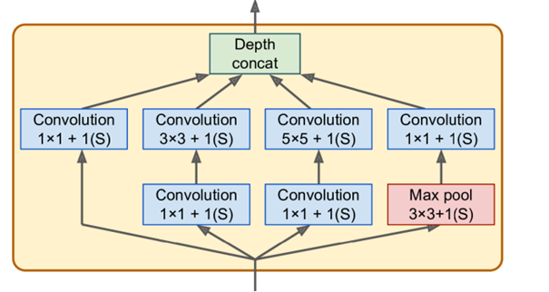

Figure 27. Inception module.

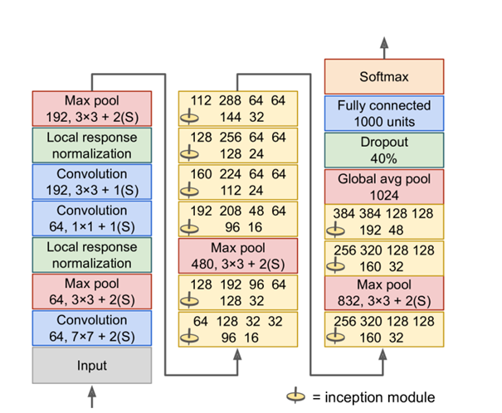

Figure 28. GoogLeNet architecture

Let’s go through this network:

- The first two layers divide the image’s height and width by 4 to reduce the computational load

- Then the local response normalization layer ensures that the previous layers learn a wide variety of features

- Two convolutional layers follow act like a bottleneck layer.

- Again a local response normalization layer ensures that the previous layers capture a wide variety of patterns.

- Next, a max pooling layer reduces the image height and width to speed up computations

- Then comes the tall stack of nine inception modules.

- Next, the global average pooling layer outputs the mean of each feature map

- The last layers are self-explanatory

* + 1. Advantages

- High performance

- Easy to deploy

* + 1. Disadvantages

- Complex architecture

- Require big data

* 1. ResNet
     1. Definition

ResNet (short for Residual Neural Network) is a convolutional neural network (CNN) architecture developed by Microsoft's research team in 2015. It achieved impressive results in the ImageNet Large Scale Visual competition Recognition Challenge (ILSVRC) 2015, won first prize in both image classification and object detection categories.

* + 1. Architecture

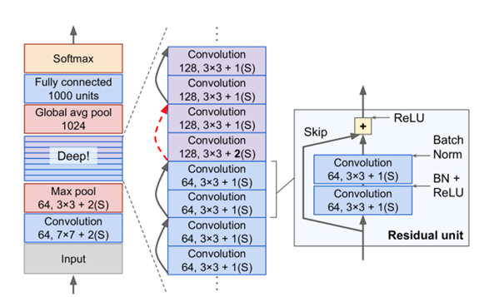

Figure 29. ResNet architecture.

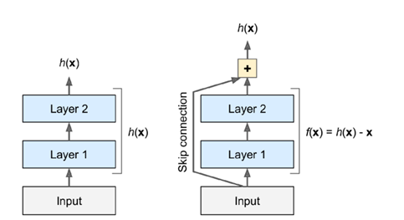

Figure 30. Residual learning.

Additionally, ResNet uses shortcut connections to connect the output of one layer to the inputs of multiple layers. This helps improve the learning ability of the network.

* + 1. Advantage

- High performance.

- Easy to deploy.

- High computational efficiency.

* + 1. Disadvantages

- Complex architecture.

- Require big data.

* 1. Xception
     1. Definition

Short for Extreme Inception, is a convolutional neural network (CNN) architecture developed by Google's DeepMind research team in 2016.

* + 1. Architecture

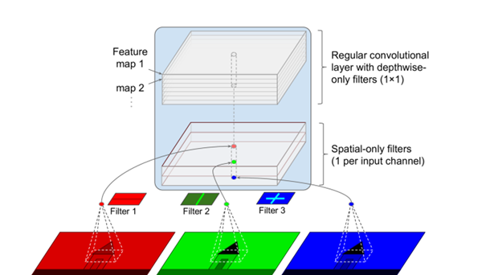

Figure 31 Depthwise separable convolutional layer.

Xception use depthwise separable convolutional layer

Depthwise separable convolutional layer will be divided into 2 parts: Depthwise convolution and Pointwise convolution to perform 2 convolutions

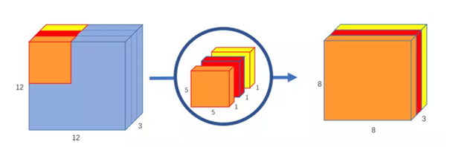

Figure 32 Depthwise convolution.

Depthwise convolution will apply a filter (kernel) to (channel) of input data independently, such as processing each channel of the image individually, and extracting spatial features.

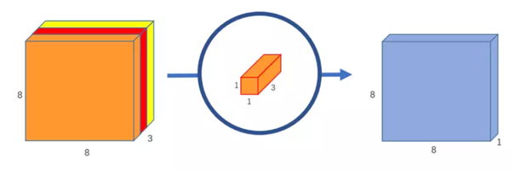

Figure 33 Pointwise convolution.

Pointwise convolution will apply 1x1 convolution on all outputs of the depth convolution. The kernel will have a number of channels equal to the number of channels of the input image.

* + 1. Advantages

- High performance

- Easy to deploy

- Can be applied to many problems

* + 1. Disadvantages

- Complex architecture

- Require big data

* 1. SENet
     1. Definition

Short for Squeeze-and-Excitation Networks, is a convolutional neural network (CNN) architecture developed by Google's DeepMind research team in 2017. It is designed to improve the performance of models CNN by learning to "focus" on important features in images.

* + 1. Architecture

SENet adds a small neural network, called an SE block, to every unit in the original architecture to extend version of others networks

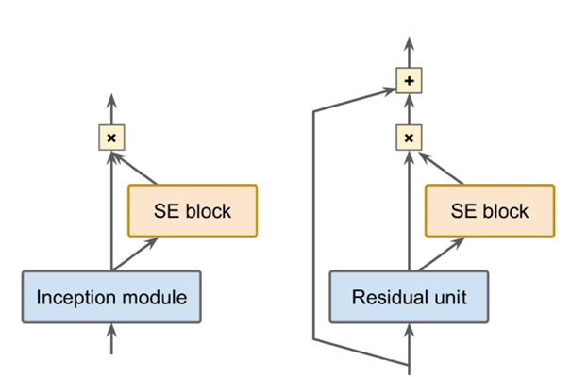

Figure 34 SE-Inception module (left) and SE-ResNet unit (right).

SE blocks focus on the depth dimension only: it recalibrates the feature maps to let them be active together (as if they are in the images).

For example, in a dataset that has mouths, noses, and eyes usually appear together in face images. Then the recalibration vector will reduce other feature maps to

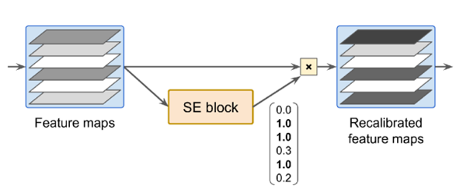

Figure 35 An SE block performs feature map recalibration.

3 layers in SE block: Global average pooling, dense, and sigmoid dense.

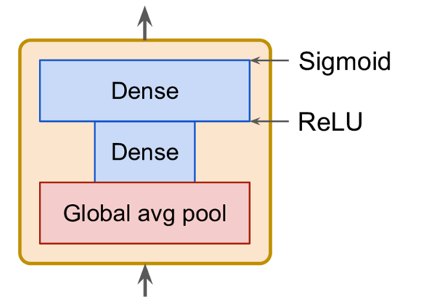

Figure 36 SE block architecture.

* + 1. Advantages

- Improve the performance

- Can be applied to many CNN architectures.

- Easy to deploy

* + 1. Disadvantages

- Adds complexity to the architecture.

- Additional data may be required for training

* 1. Comparison between CNNs architectures

|  |  |  |  |  |  |  |
| --- | --- | --- | --- | --- | --- | --- |
| **Feature** | **LeNet-5** | **AlexNet** | **GoogleNet** | **ResNet** | **Xception** | **SENet** |
| Year Released | 1998 | 2012 | 2014 | 2015 | 2016 | 2017 |
| Architecture | Simple convolutional neural network | Multi-layer convolutional neural network | Inception architecture | Residual architecture | Inception architecture with depthwise separable convolutional blocks | SE (Squeeze-and-Excitation) architecture |
| Number of Parameters | ~300,000 | ~60 million | ~1.3 million | ~10 million | ~35 million | ~112 million |
| Performance | Good on small datasets | Good on large datasets | Good on large datasets | Good on large datasets | Good on large datasets | Good on large datasets |
| Computational Efficiency | High | Medium | High | High | High | Medium |
| Ease of Implementation | Easy | Difficult | Medium | Medium | Medium | Medium |
| Applicability to Diverse Tasks | Possible | Possible | Possible | Possible | Possible | Possible |

CHAPTER 8: OBJECT DETECTION

1. 1. Introduction
      1. Definiton

Object detection is a technique that uses neural networks to localize and classify objects in images. This computer vision task has a wide range of applications, from medical imaging to self-driving cars.

* + 1. Compare Object detection and Classfication.

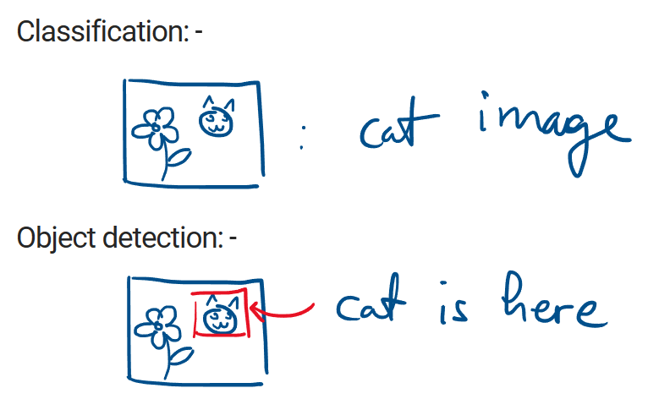

Figure 37 Compare Object detection and Classification.

**In Classification**, It is a process of categorizing data or objects into predefined class based on their features. In this example it can know as the image is **cat image** but it can not define where is object appear in that image. But **Object detection** can define the cat and show up the bounding box in the image.

* + 1. Structural of Object Detection

**- Bounding box:** predict and bound the object in the box.

**- Object labeling:** allow user know the name of object.

* 1. To detect multiple objects
     1. Sliding CNNs

For multiple objects in an image:

Step 1: Train a CNN to classify and locate a single object.

Step 2: Slide it across the image.

Step 3: Zoom it and slide again.

* + 1. Non-max suppression

Step 1: Measure probability that the objects is in the box.

Step 2: Keep only 1 box with highest probabilitya: among overlapped boxes.

* + 1. Fully convolutional network

Replace the dense output layers by convolutional layers.

→ Only con volutional layers in the NN.

Two ways to create a FCN

Method 1: Design the model and train

Method 2: Convert a CNN to FCN: convering a Dense to Conv2D layer requires.

Example of FCNs

1.Train a CNN to detect single object in 224x224 images, that outputs 10 numbers:

+ 5 class probabilities

+ 1 objectness score

+ 4 bbox coordinates

 2. Convert the CNN to FCN

 3.Input a 448x448 image

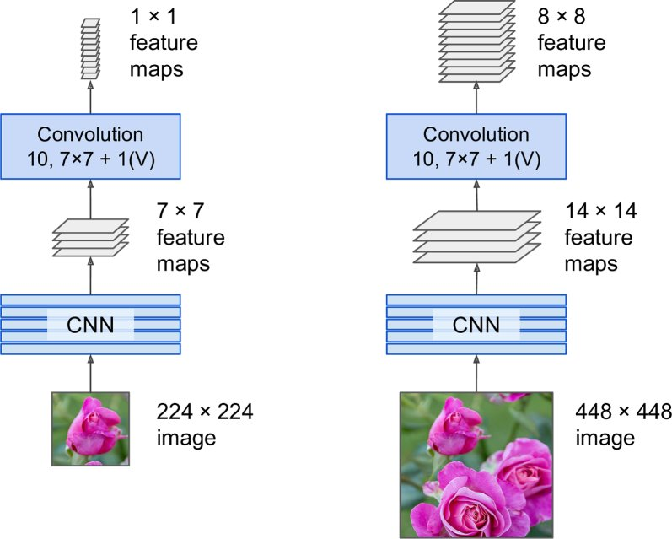

Figure 38 Example of FCNs.

* 1. Measure Mean Average Precision (mAP)

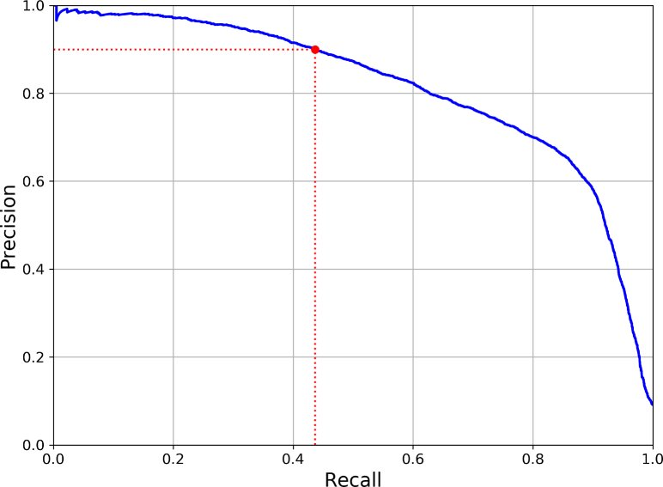

To get the classification performance

Step 1: Compute the maximum precision with at least.

Step 2: Calculate the average of these maximum precisions.

Step 3: When there are more than 2 classes.

- In classification, predicting the right class

- In object detection, detecting the right class, but with wrong box.

* 1. Computer vision problem.

**- Semantic segmentation:** only classify pixels into class

**- Instance segmentation:** classify pixel into distinguished instances.

**- Single-shot learning**

**- Realistic image generation**

**- Explainability**

CHAPTER 9: PROCESSING SEQUENCES USING RNN

1. 1. Introduction
      1. Definition

Recurrent Neural Network (RNN) is a type of Neural Network where the output from the previous step is fed as input to the current step. In traditional neural networks, all the inputs and outputs are independent of each other. Still, in cases when it is required to predict the next word of a sentence, the previous words are required and hence there is a need to remember the previous words.

* 1. RNN’s fundamental concepts
     1. Recurrenth neurons

A recurrent neuron looks very much like a feedforward neuron. This unit has the unique ability to maintain a hidden state, allowing the network to capture sequential dependencies by remembering previous inputs while processing.

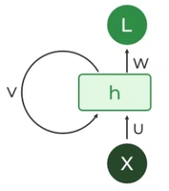

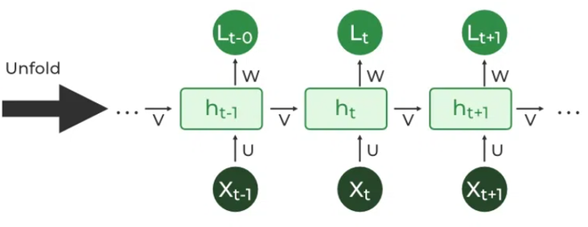

Figure 39. Recurrent neurons architecture.

* + 1. Weight of recurrent neurons

Each recurrent neuron has 2 sets of weights:

**Whh**: Weight at recurrent neuron

**Wxh:** Weight at input neuron

→ Weights are same across all the layers number of a Recurrent Neural Network

* + 1. Input and output of RNNs

- An RNN takes a sequence of inputs and produces a sequence of outputs.

- An RNN takes a sequence of inputs and produces the single last output

- An RNN takes the same single input and produces a sequence of outputs.

- Combine (Encoder - Decoder)

* + 1. Time series

A sequence of one or more values per time step

- Single value per time step

- Multiple values per time step

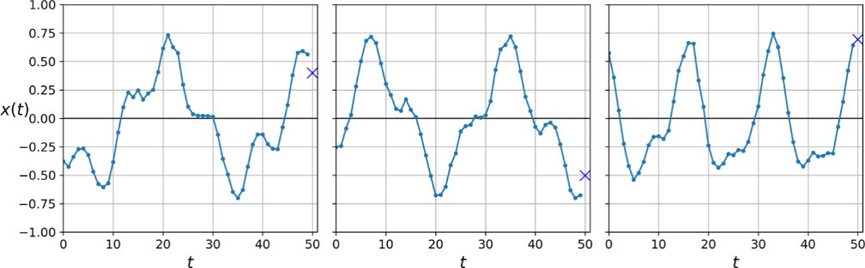

Figure 40. Time series.

* 1. Variants of LSTM Cells and Other NNS that Handles sequential data

**LSTM cells**: is a crucial component in the field of deep learning, specifically within recurrent neural networks.

**GRU cells:** is similar to an LSTM cell but with a streamlined architecture. It aims to address the vanishing gradient problem while being computatuionally efficient.

* + 1. RNNs with 1D conv layers

Conv1D layers are inspired by their 2D counterpart but operate along a single dimension. They consist of a stack of Conv1D filters that slide over the input sequence capturing local patterns. CónD layers are computationally efficient and can learn meaningful features from sequence data.

* + 1. WaveNet

Using only Conv1D layers, Recall Conv layers can handle inputs of any size.  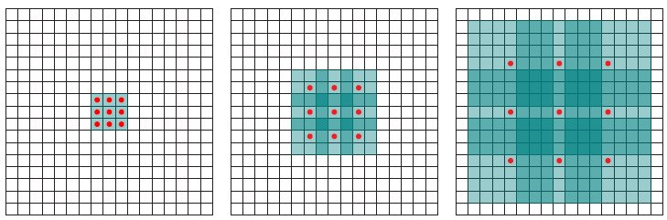

Figure 41 Dilation rate.

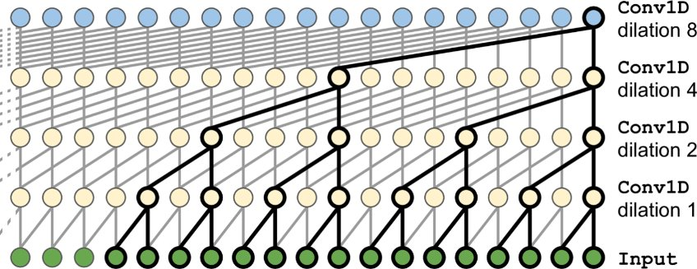

Figure 42 Comparision of Deep Learning techniques.

Architecture of WaveNet:

- 10 conv layers with dilation rates of 1, 2, 4, 8, …, 246, 512

- Then an identical group of 10 conv.layers.

- Then again another identical group of 10 layers

🡪Each of these stacks of 10 conv layers act like a super efficient conv layer with a kernel of size 1,024.

PROJECT: FACE RECOGNITION

1. LIBRARIES
   1. ARCFACE MODEL

ArcFace is a face recognition model developed by researchers at the Beijing University of Posts and Telecommunications. It is designed to handle challenging face recognition scenarios by learning discriminative features in face images. The key innovation of ArcFace lies in its angular softmax loss function, which enhances the discriminative power of the learned features. This loss function encourages the model to project face images into a hypersphere space where intra-class variations are minimized while inter-class variations are maximized. As a result, ArcFace achieves state-of-the-art performance on various face recognition benchmarks.

* 1. MTCNN (Multi-task Cascaded Convolutional Networks)

MTCNN is a popular face detection and alignment algorithm proposed by researchers at the Chinese Academy of Sciences. It consists of three stages: face detection, bounding box regression, and facial landmark localization. In the first stage, MTCNN uses convolutional networks to detect candidate face regions in an image. Then, it refines these detections by applying bounding box regression to improve the accuracy of the bounding boxes. Finally, MTCNN estimates facial landmarks such as eyes, nose, and mouth positions within the detected faces. MTCNN is widely used as a pre-processing step for face recognition systems due to its robustness and efficiency.

1. MODEL ARCHITECTURE

ARCFACE RECOGNITION MODEL

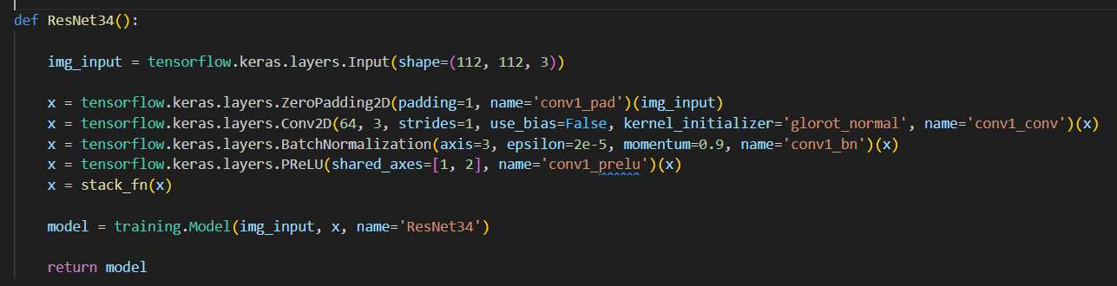

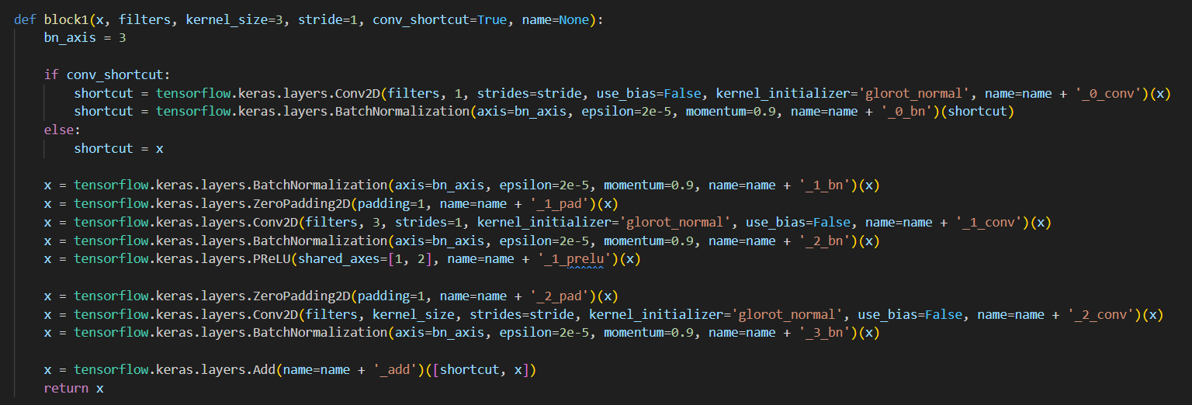

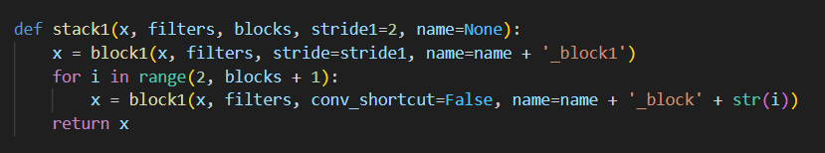

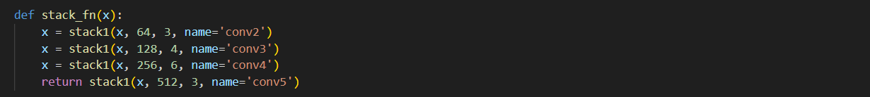

Define model ResNet34 be the base model.

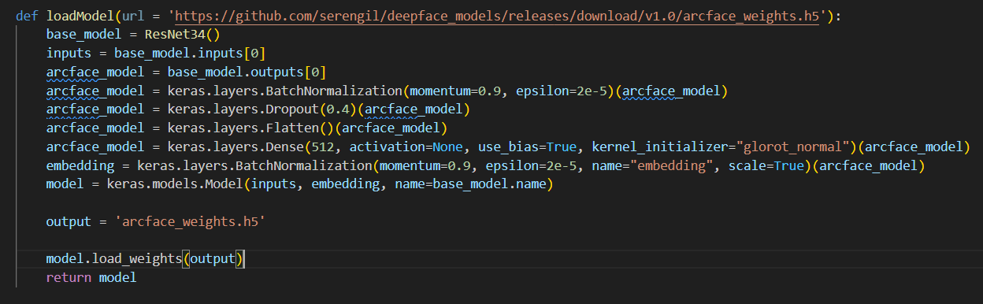

1. DATASET

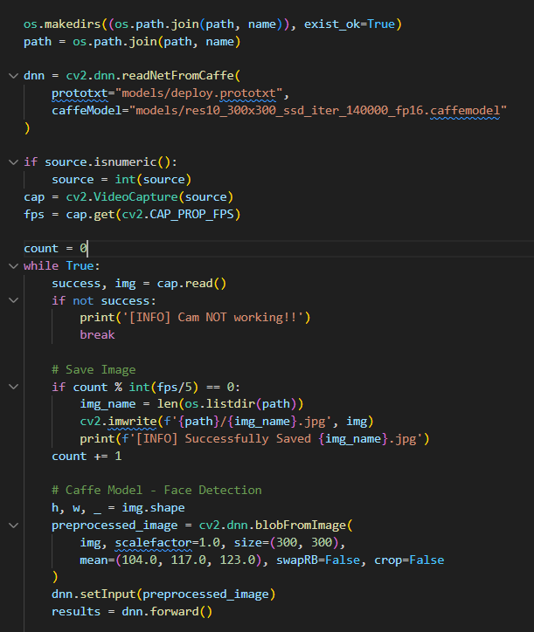



Capture face dataset of each person by webcam and store them in ‘User Name’ folder which is a sub-folder of dataset directory.

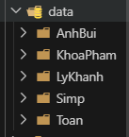

1. DATASET PRE-PROCESSING

Use MTCNN to remove background and extract face from image dataset by determining image roi and rotate the input image from a specific point. This point is based on triangle edges defined by distance to left eye and right eye.

After the pre-processing step, the normalized dataset will be stored in norm data.

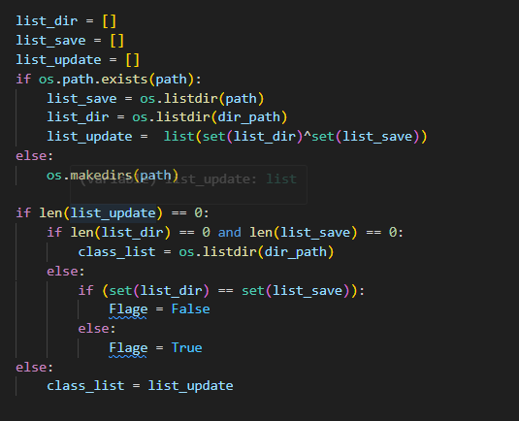

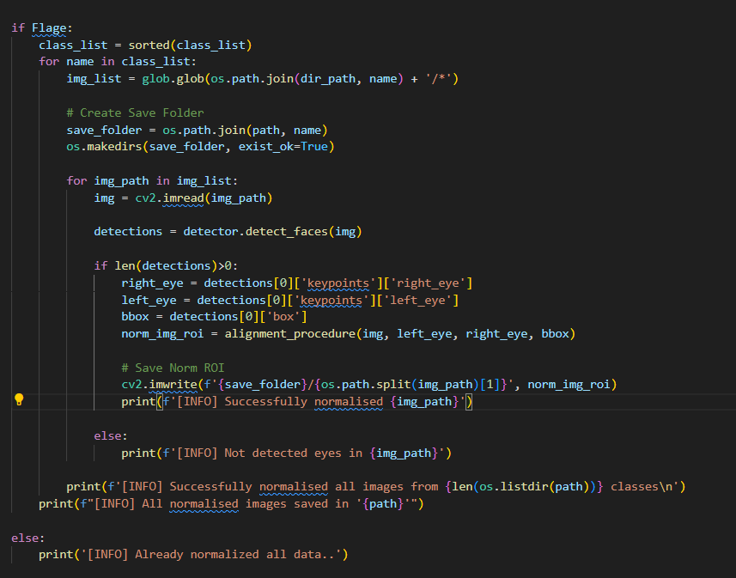

1. MODEL TRAINING


5. 1. GET EMBEDDING IMAGE DATA

Use the ArcFace model to get embedding vectors from every image in the dataset.

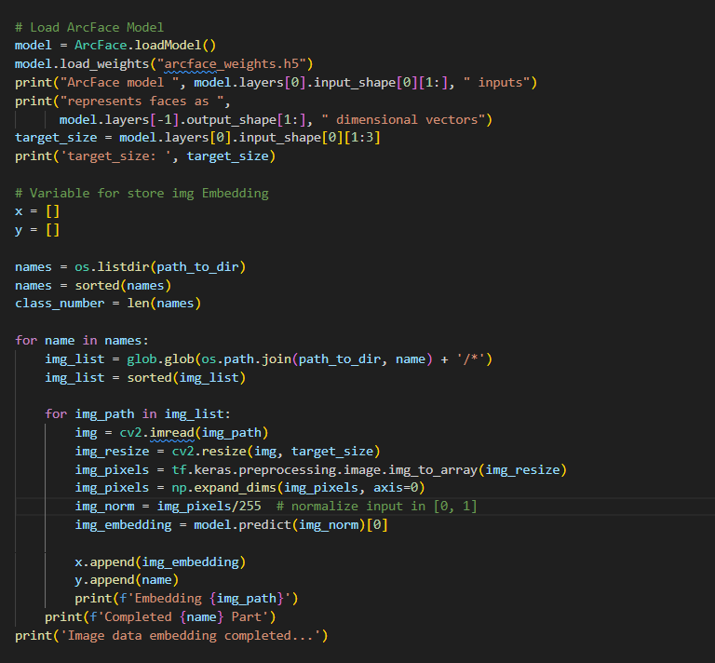

* 1. TRAIN RECOGNITION MODEL

Use embedded data to train a model to give classification.

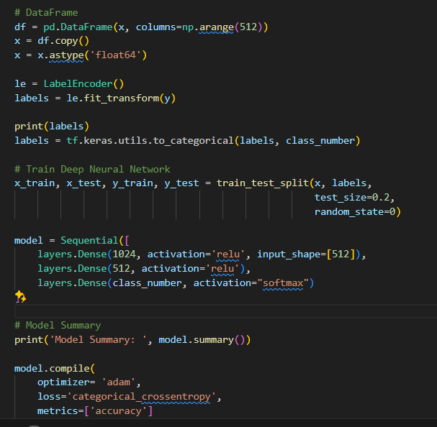

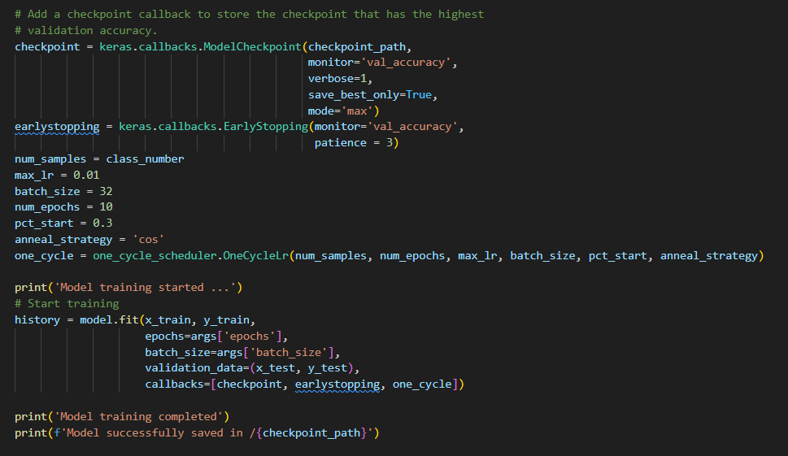

- Use Model Checkpoint to save model whether it has good performance in test dataset.

- Use Early Stopping callback to stop training model if it validation accuracy does not improve after 3 epochs.

- Define one_cycle_scheduler to adjust learning rate to optimize the training process with max learning rate is 0.01

1. Mark Attendance

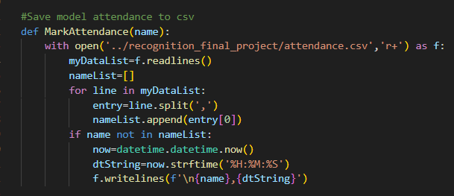

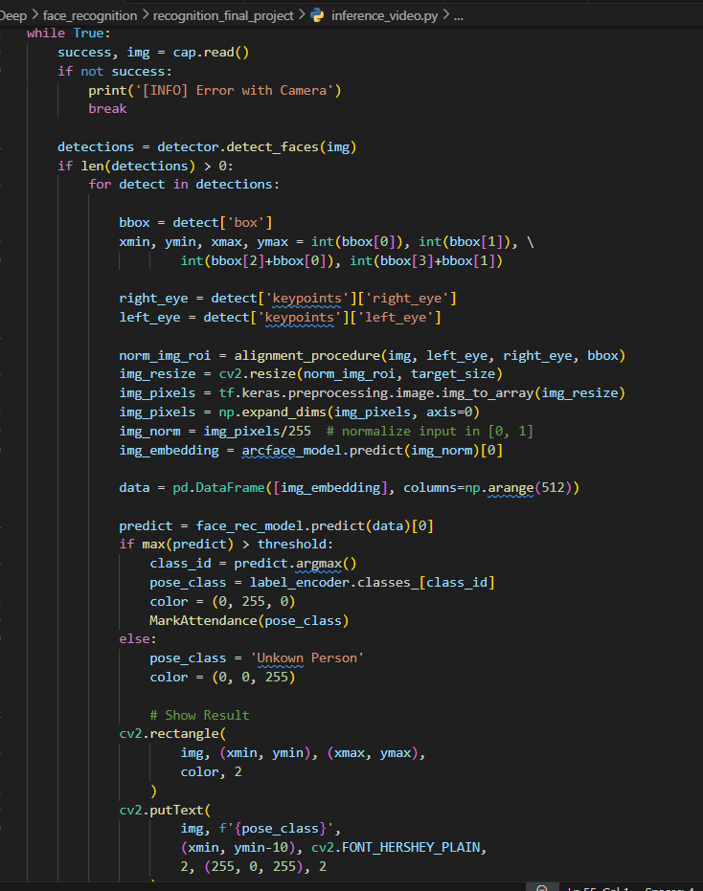

While running realtime camera, if any faces recognized, the label class name and time will be written to Attendance.csv file.

1. APPLICATION DEMONSTRATION

Run streamlit: streamlit run app.py

2. 1. Collect dataset

Open location folder name terminal, and run below command:

python take_imgs.py --source 0 --name KhanhTran --save data --conf 0.8 --number 120

With config:

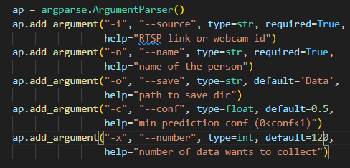

* 1. Normalize dataset

Run below command:

python norm_img.py --dataset data/ --save norm_data

With config:

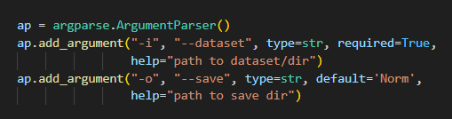

The output will display:

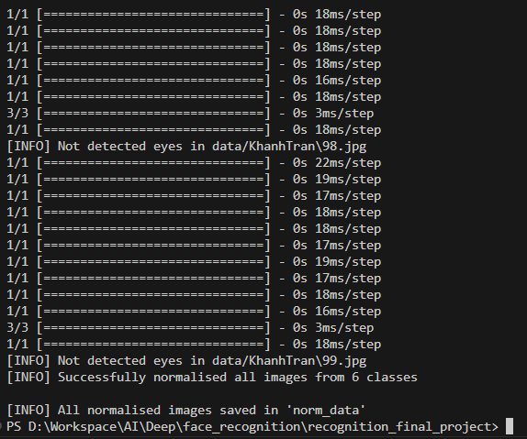

* 1. Train model:

Run below command:

python train.py --dataset norm_data/ --batch_size 32 --epochs 100

The output will display some information:

+ The ResNet34 model sumary:

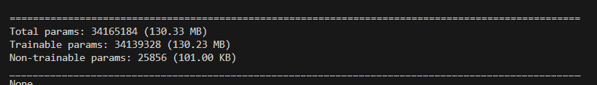

+ The embedding dataset process:

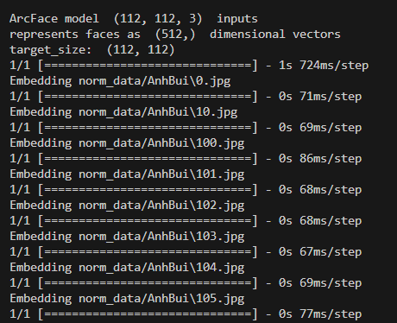

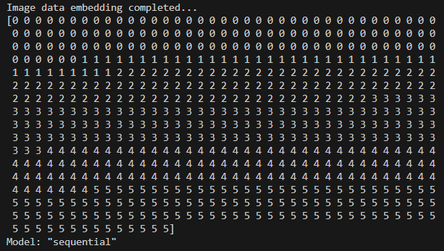

+ The recognition model sumary:

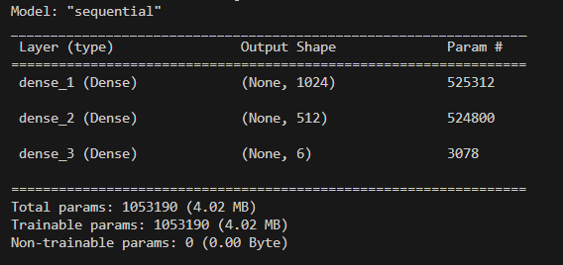

+ Training process:

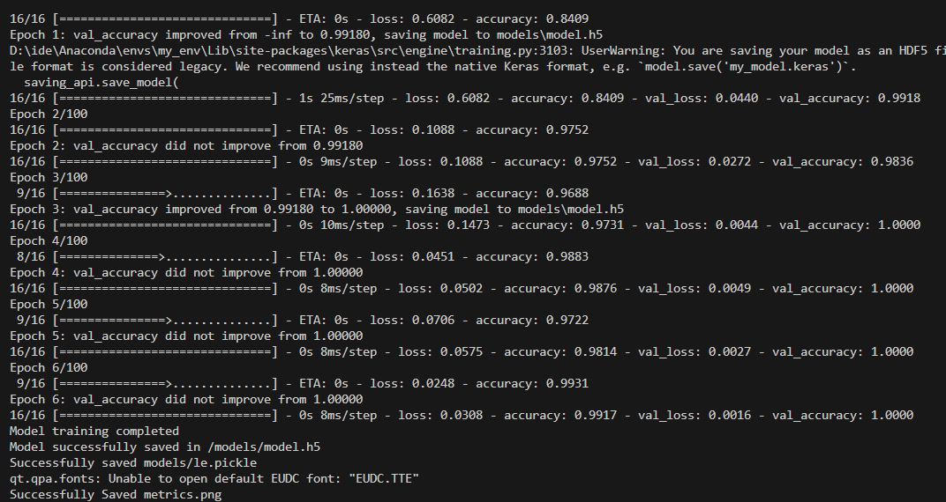

+ Model metrics:

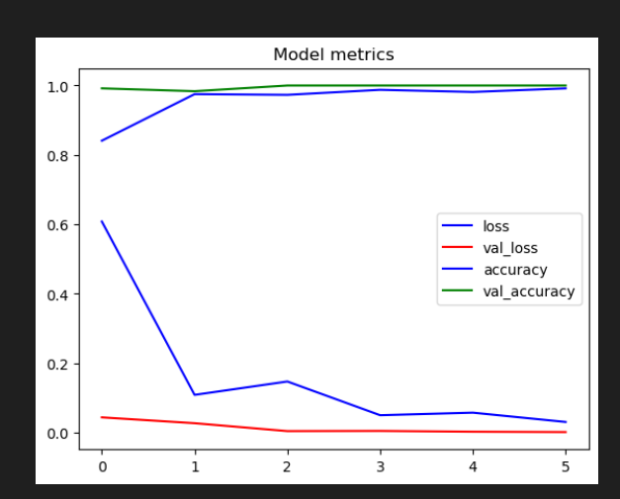

* 1. Realtime Recognition:

Run below command:

python inference_video.py --source 0 --model models/model.h5 --conf 0.85 --label_encoder models/le.pickle

+ Result:

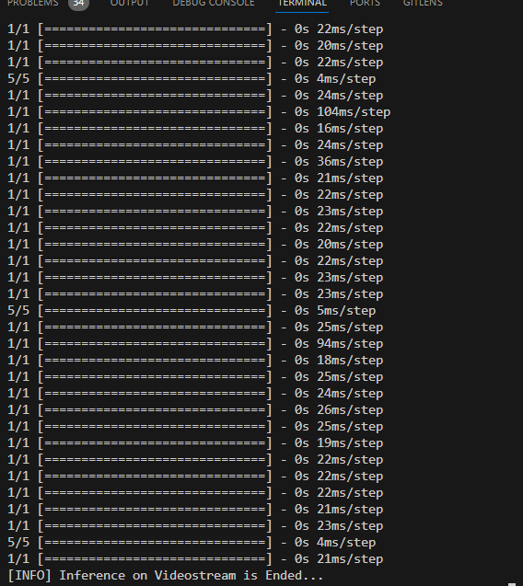

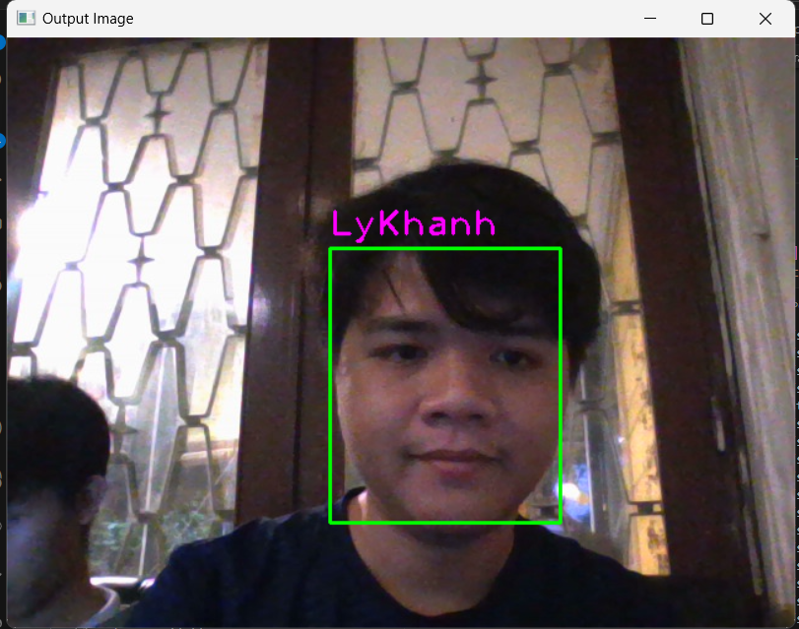

+ Open the attendance.csv file to view saved attendances checked:

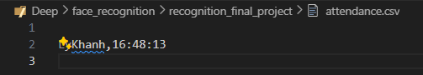

# **REFERENCES**

Géron, A. (2019). Freec. In A. Géron, *Hands-on machine learning with Scikit-Learn, Keras, and TensorFlow: Concepts, tools, and techniques to build intelligent systems. O'Reilly Media.*

Huyen, N. T. (2021, 8 16). *Viblo*. Retrieved from [Paper explained] Some Face Recognition Approaches: Facenet, ArcFace, CosFace: https://viblo.asia/p/paper-explained-some-face-recognition-approaches-facenet-arcface-cosface-Do754zgLZM6

*ScienceDirect*. (2024, 5 8). Retrieved from Comparison of Various Learning Rate Scheduling Techniques on Convolutional Neural Network, IEEE Xplore: https://www.sciencedirect.com/topics/engineering/data-preprocessing

*What is a neural network?* (2024, 5 8). Retrieved from ibm.com: https://www.ibm.com/topics/neural-networks